**MONTIORING WITH NAGIOS**

**What is Nagios:**

Nagios is an open source monitoring system that helps to monitor the health and performance of IT components such as servers, network devices, applications, and services. It provides a central monitoring framework that allows users to monitor multiple hosts and services using a variety of plugins. Nagios can alert administrators when problems arise or when certain thresholds are exceeded, allowing them to quickly respond and take corrective action before problems become more severe.

## Why Nagios:

Nagios offers the following features making it usable by a large group of user community −

* It can monitor Database servers such as SQL Server, Oracle, Mysql, Postgres
* It gives application level information (Apache, Postfix, LDAP, Citrix etc.).
* Provides active development.
* Has excellent support form huge active community.
* Nagios runs on any operating system.
* It can ping to see if host is reachable.

**Benefits of Nagios:**

Nagios offers the following benefits for the users −

* It helps in getting rid of periodic testing.
* It detects split-second failures when the wrist strap is still in the “intermittent” stage.
* It reduces maintenance cost without sacrificing performance.
* It provides timely notification to the management of control and breakdown.

## Nagios Architecture

The following points are worth notable about Nagios architecture −

* Nagios has server-agent architecture.
* Nagios server is installed on the host and plugins are installed on the remote hosts/servers which are to be monitored.
* Nagios sends a signal through a process scheduler to run the plugins on the local/remote hosts/servers.
* Plugins collect the data (CPU usage, memory usage etc.) and sends it back to the scheduler.
* Then the process schedules send the notifications to the admin/s and updates Nagios GUI.

1.First Login to AWS console page and go to the service EC2 Dashboard.

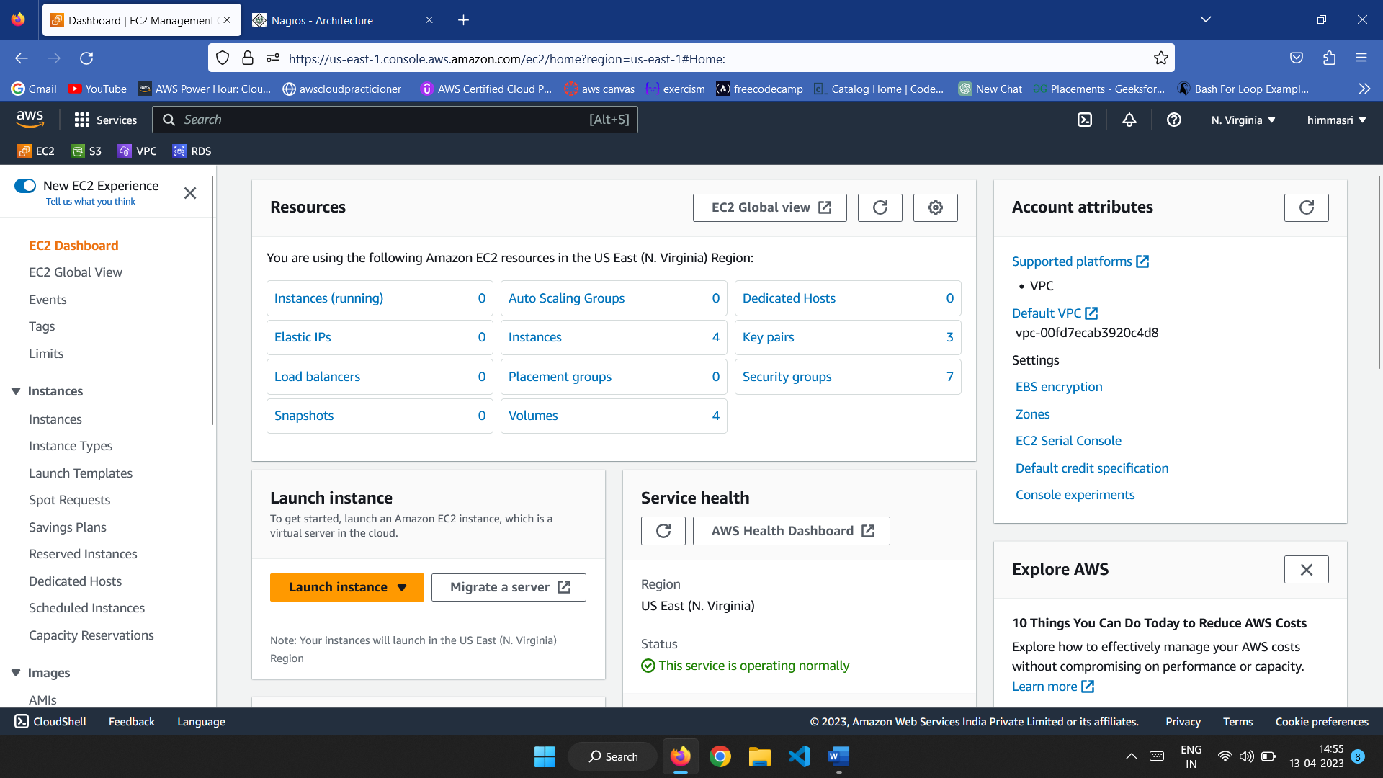

2.Click on Launch instances to launch instance

3.Give name to your instance

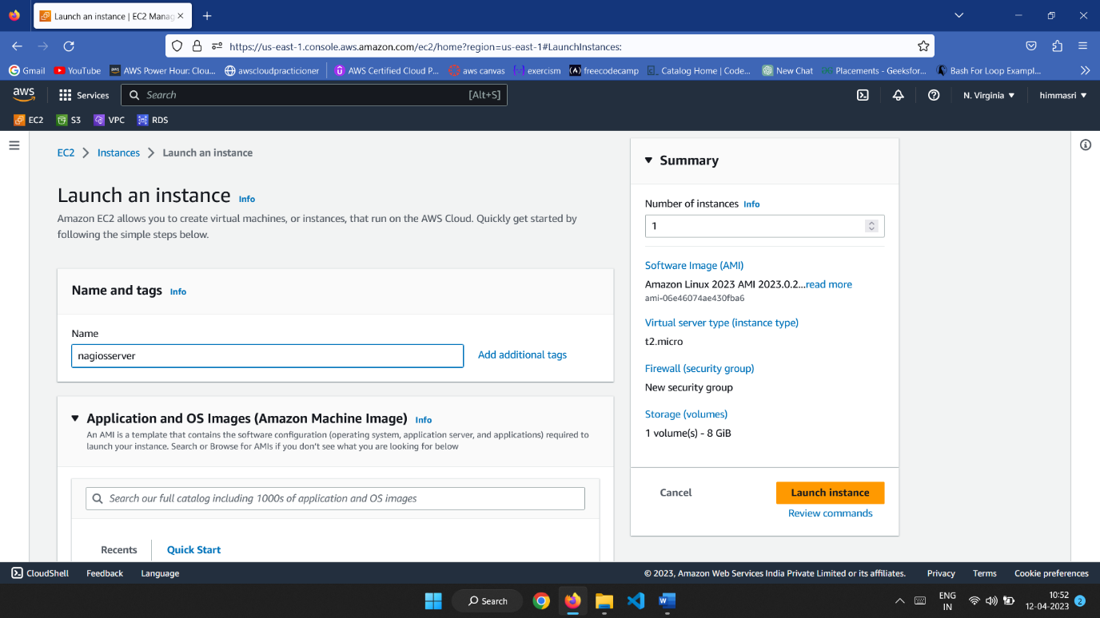

4.Select Amazon linux as Amazon Machine Image

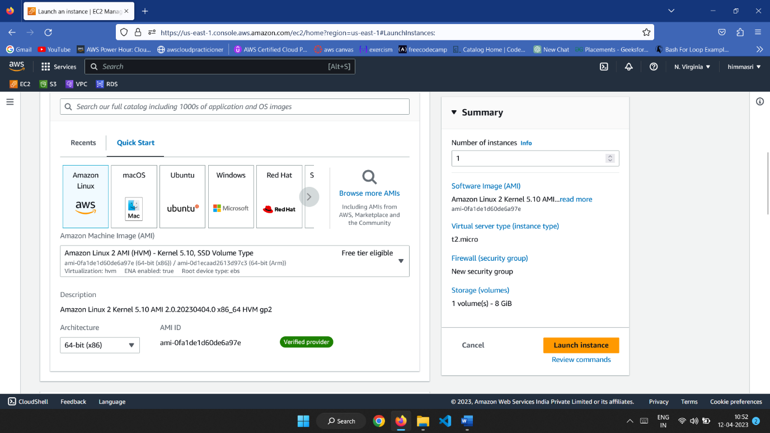

5.Create new key pair in ppk format or pem format or choose an exist one .

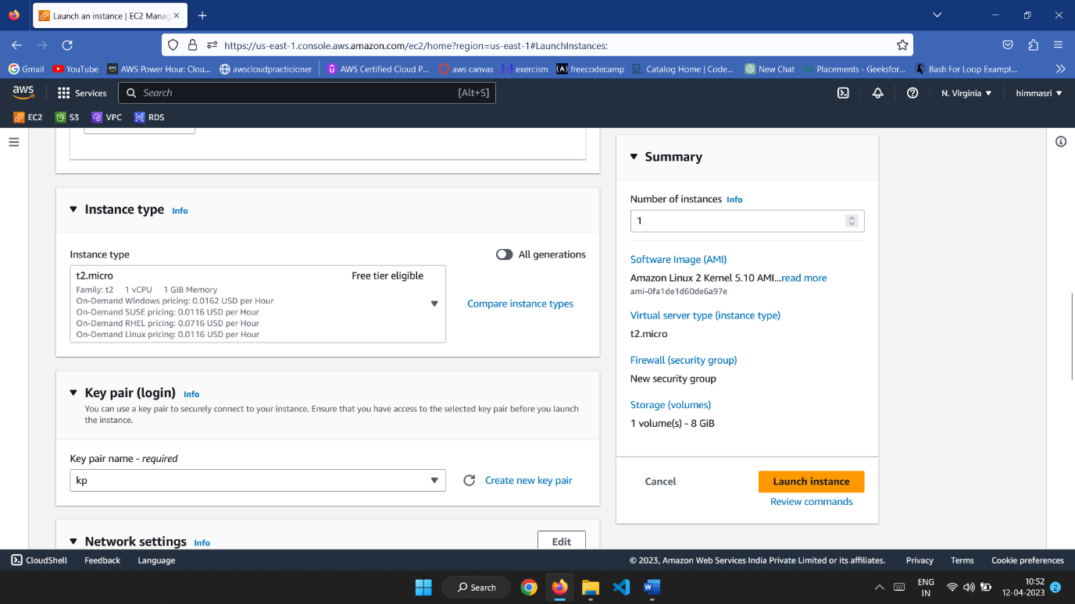

6.In network settings use default VPC and default subnet

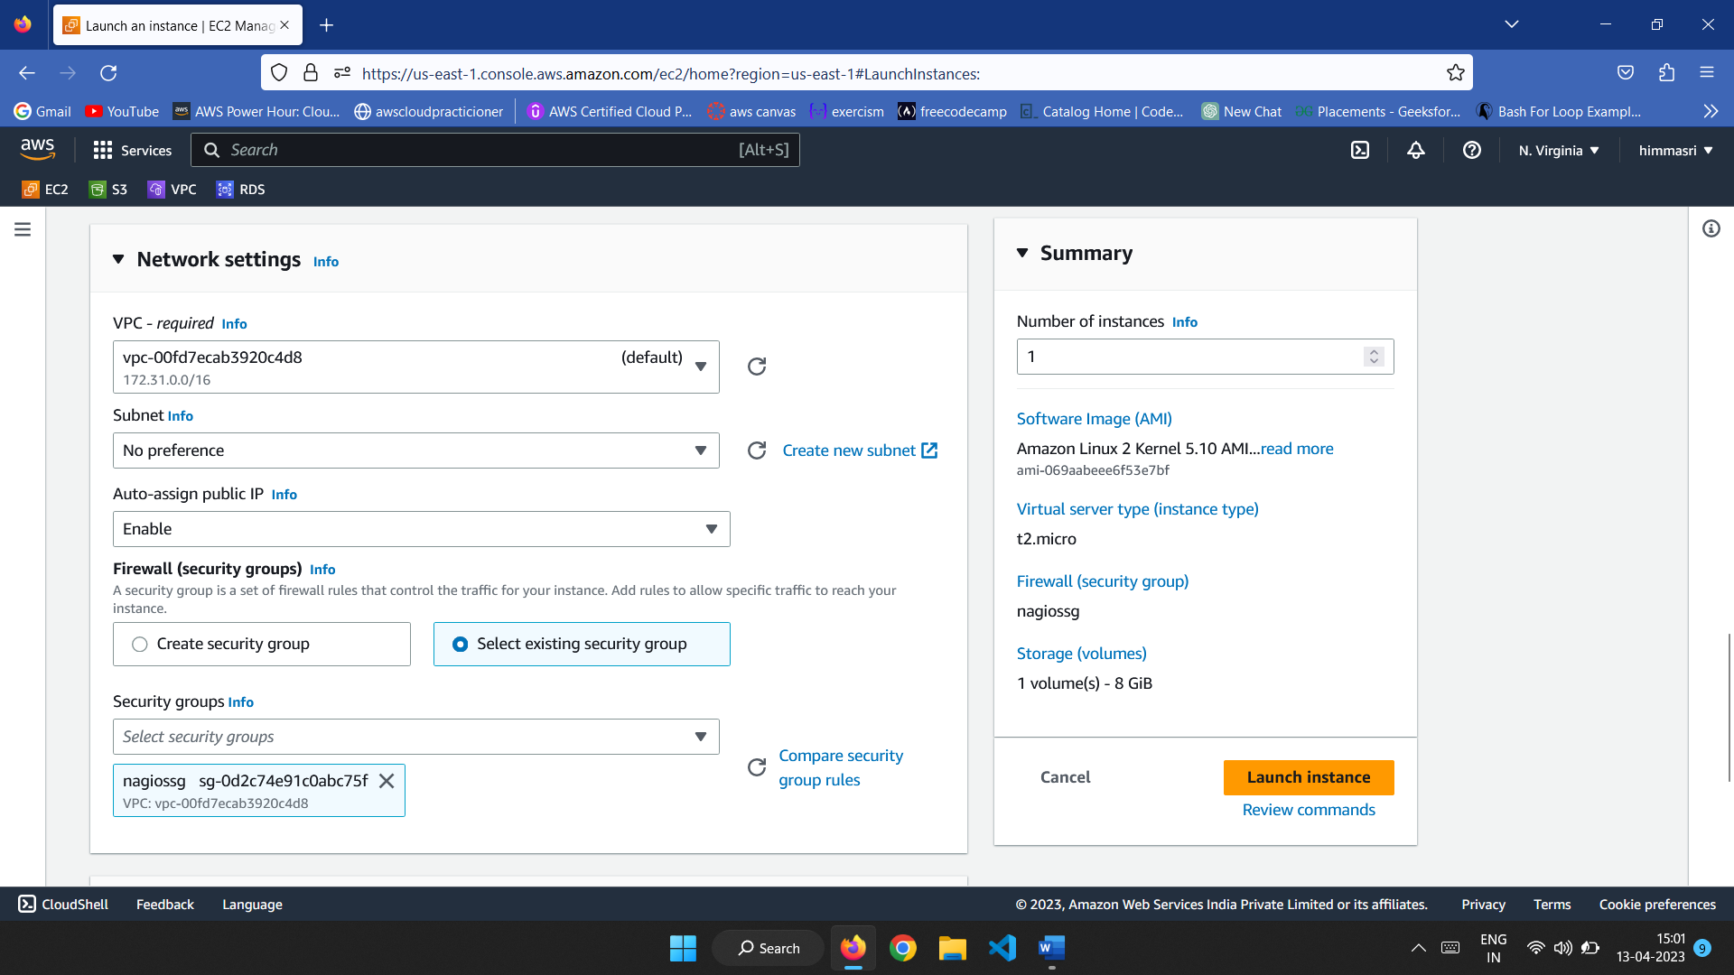

7.Create new security group and edit inbound rules as ssh type with source type as anywhere and http,https also.

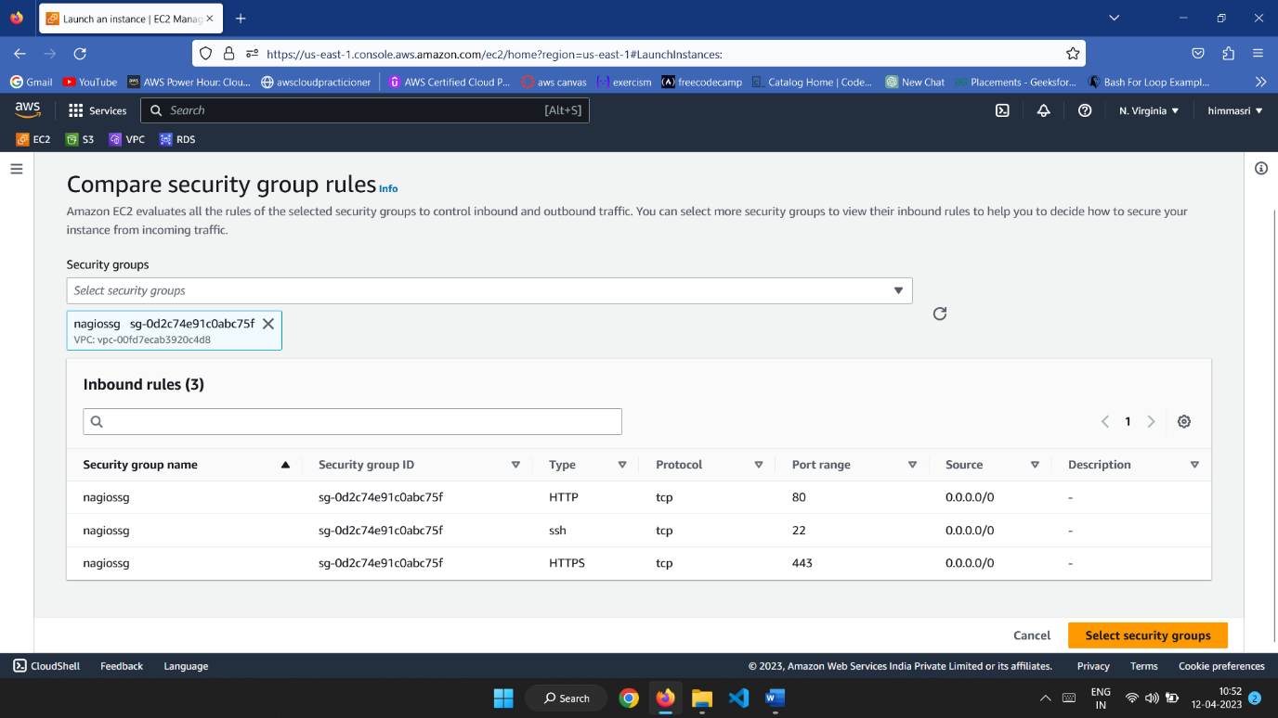

8.Click on launch instance to create an instance

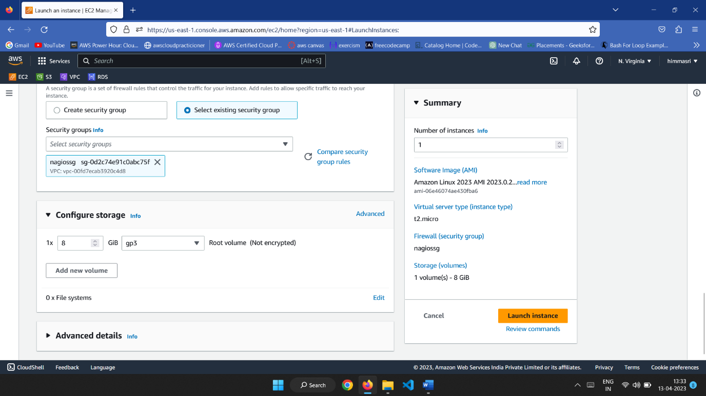

9.Now the instance will be created.

10.The instance can be seen in running state in instance dashboard.

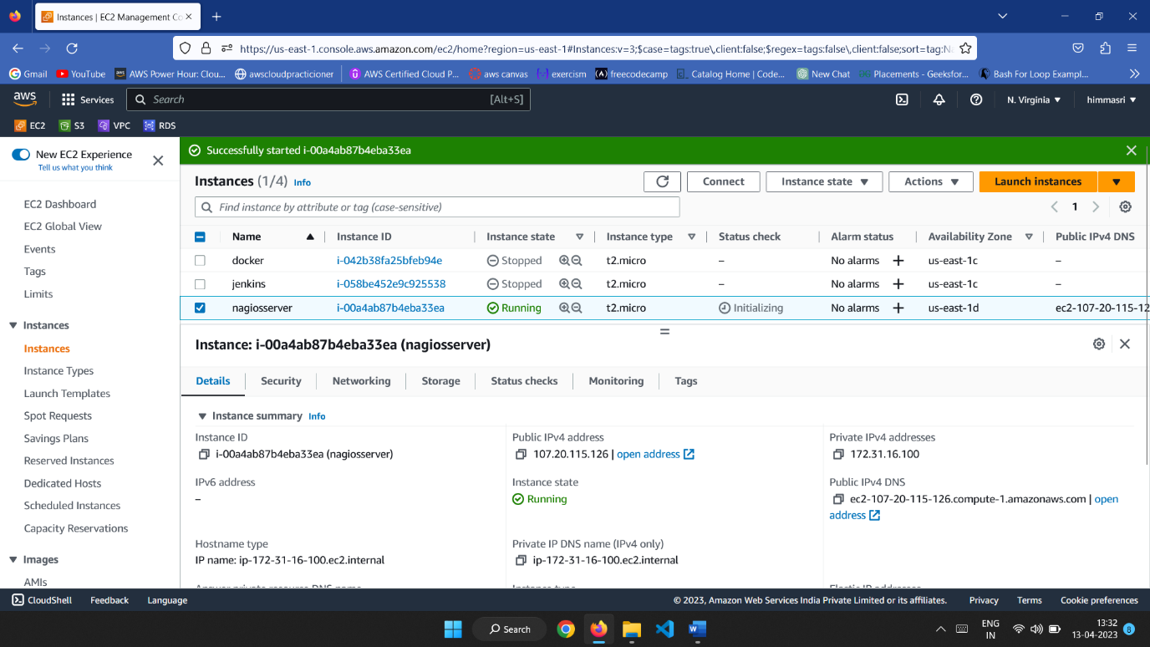

11.Connect to EC2 instance using aws console or putty or local machine.

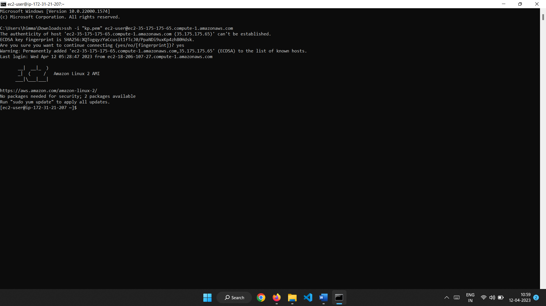

**Step 1:** Now we need to install some prerequisite softwares such as apache,php,gcc compiler, GD development libraries using the following commands.

sudo yum install httpd php

sudo yum install gcc glibc glibc-common

sudo yum install gd gd-devel

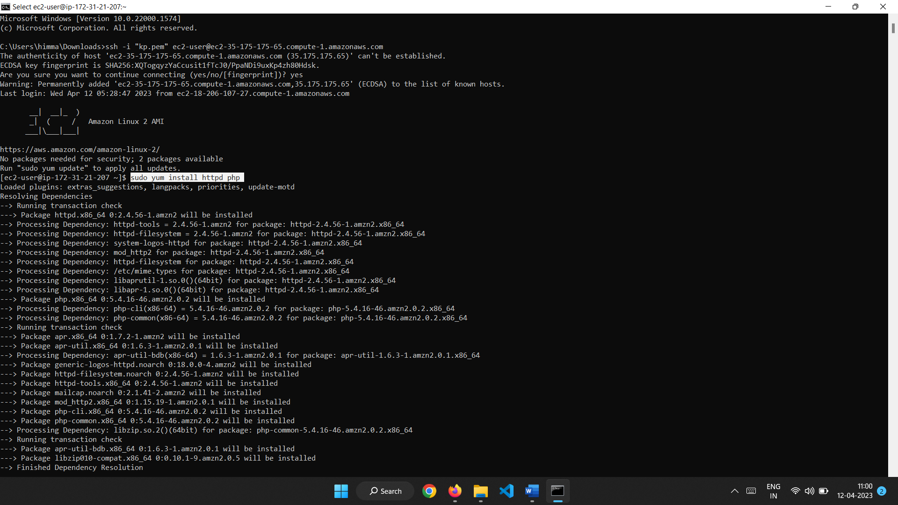

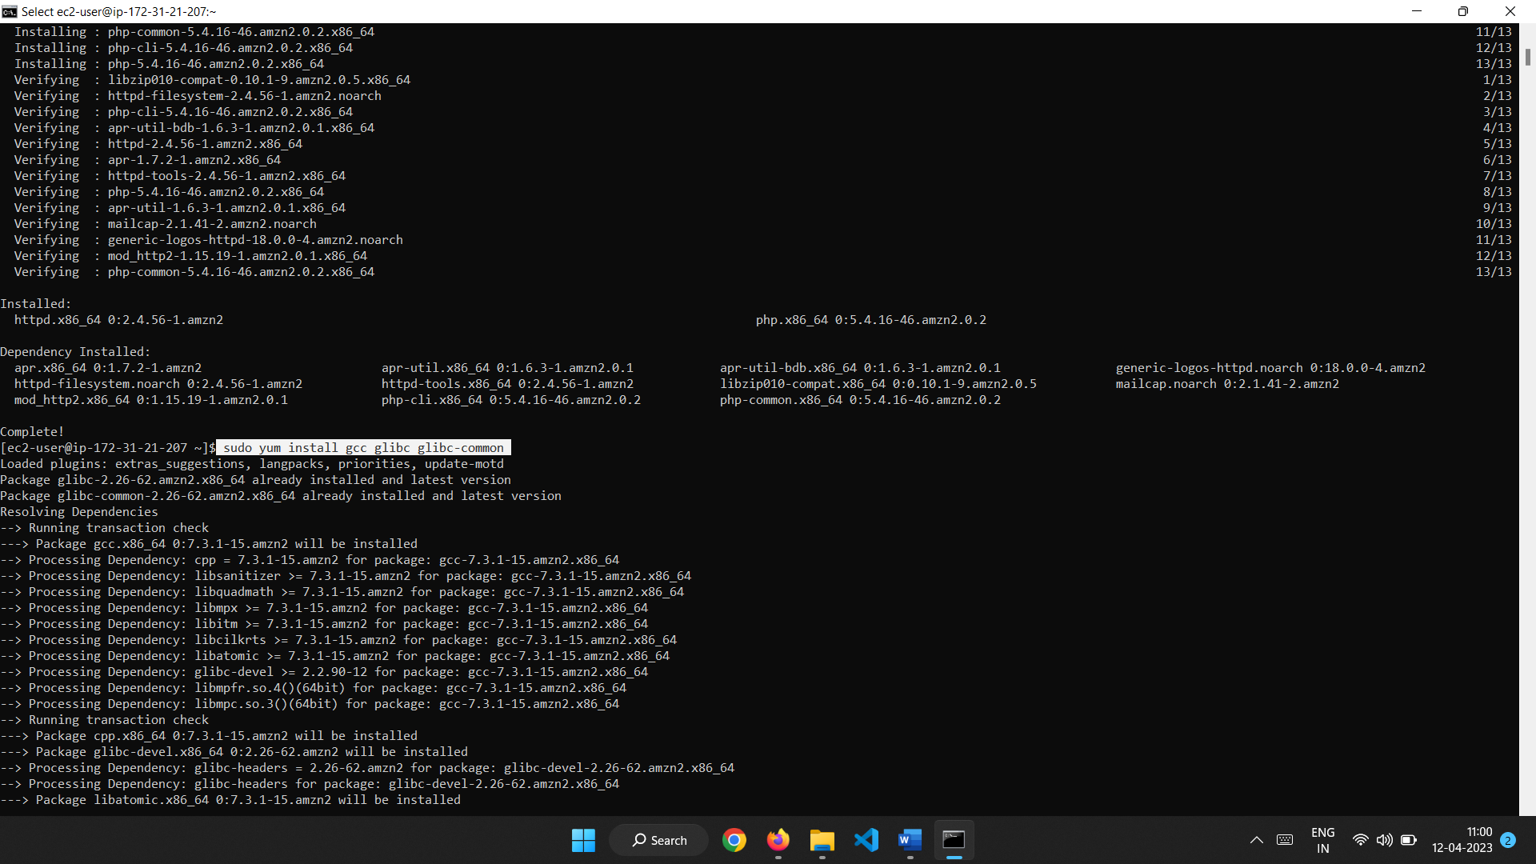

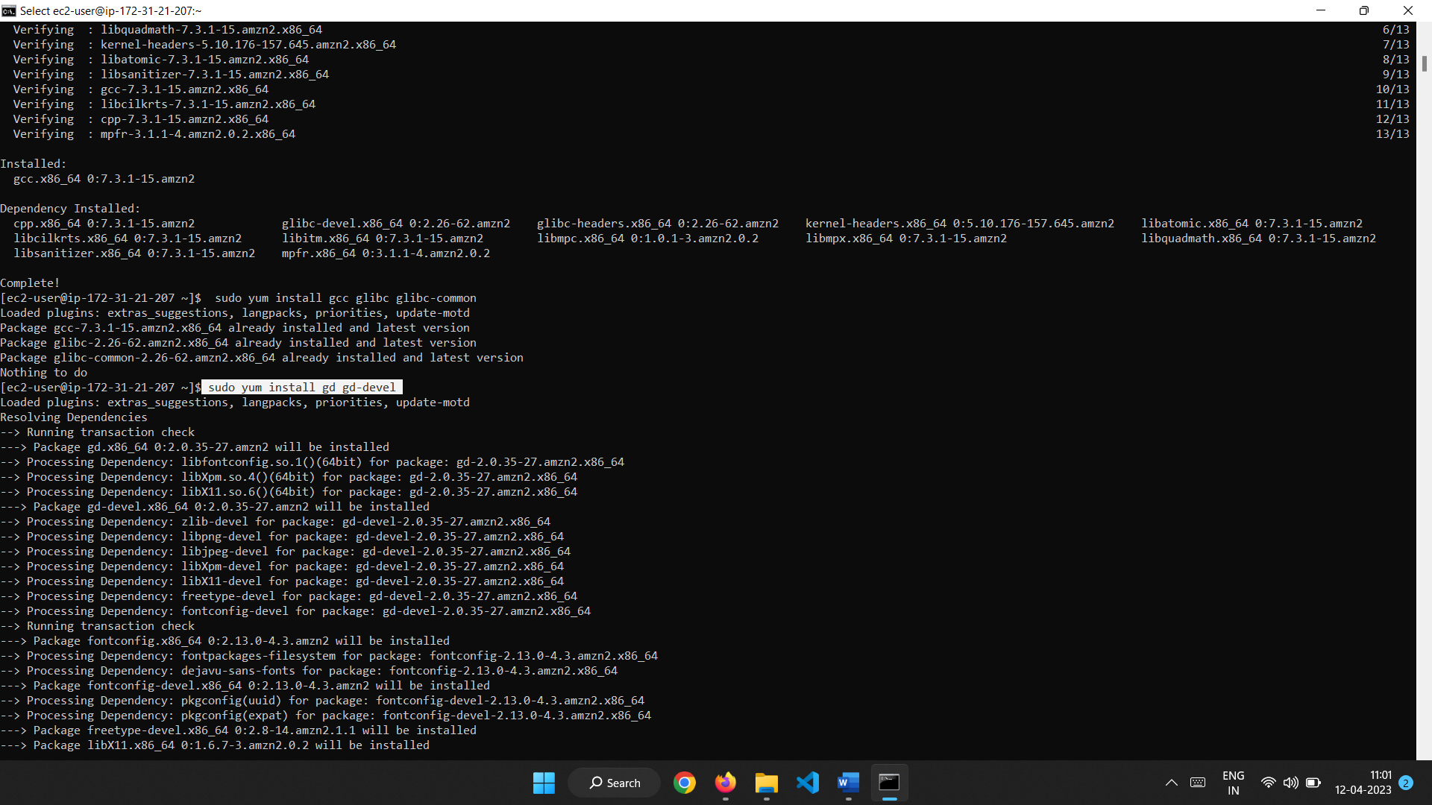

**Step 2: Create Account Information**

You need to set up a Nagios user. Run the following commands:

**$sudo adduser -m nagios**

**$sudo passwd nagios**

Type the new password twice.

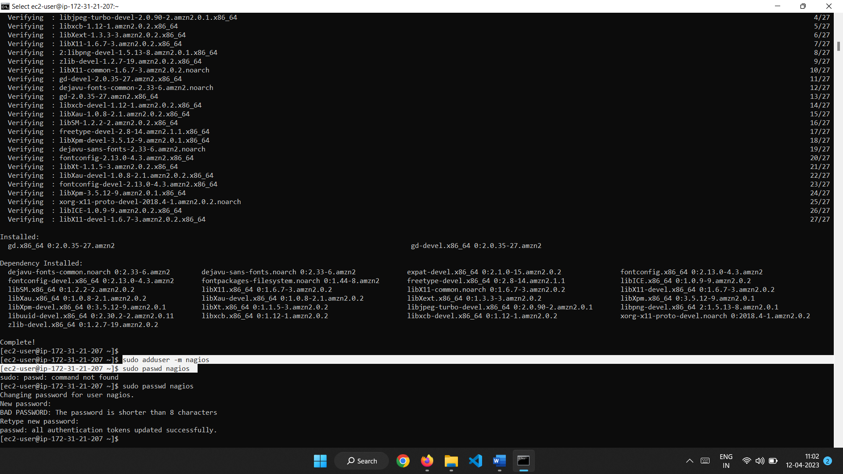

**sudo groupadd nagcmd**

**sudo usermod -a -G nagcmd nagios**

**sudo usermod -a -G nagcmd apache**

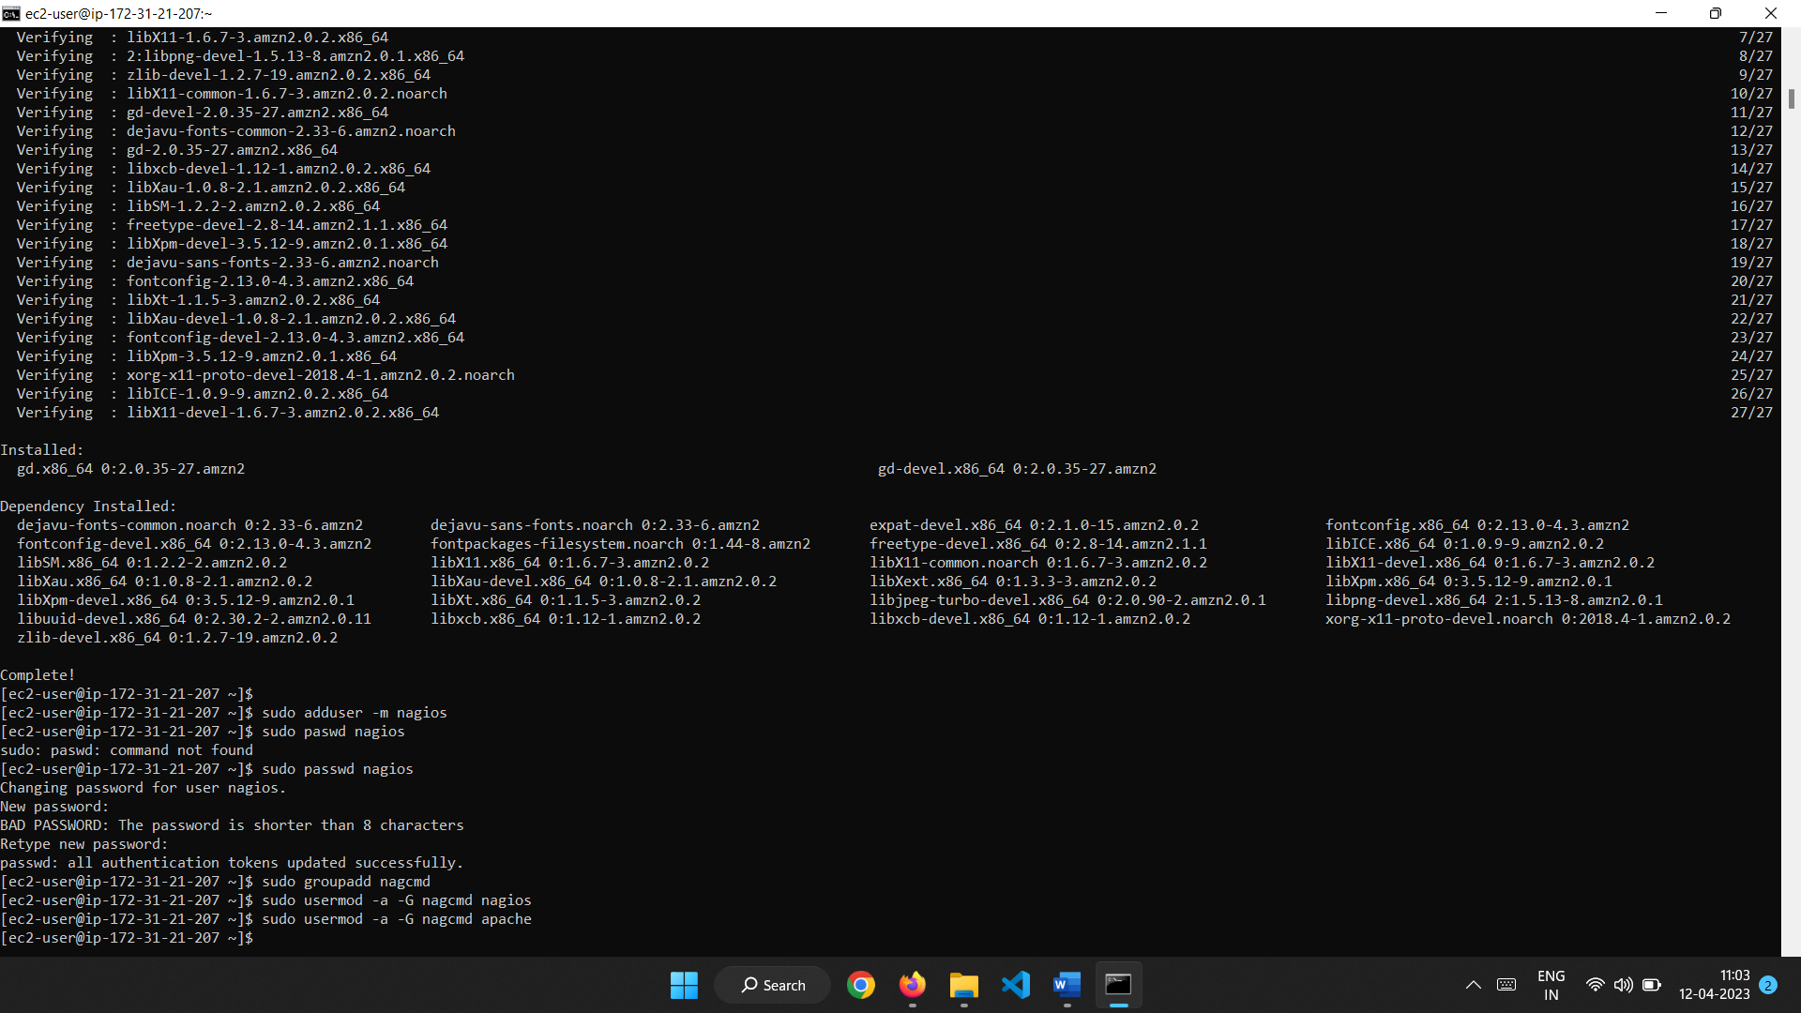

**Step 3: Download Nagios Core and the Plugins**

Create a directory for storing the downloads ie nagios and nagios plugins.

mkdir ~/downloads

cd ~/downloads

wget <http://prdownloads.sourceforge.net/sourceforge/nagios/nagios-4.0.8.tar.gz>

wget http://nagios-plugins.org/download/nagios-plugins-2.0.3.tar.gz

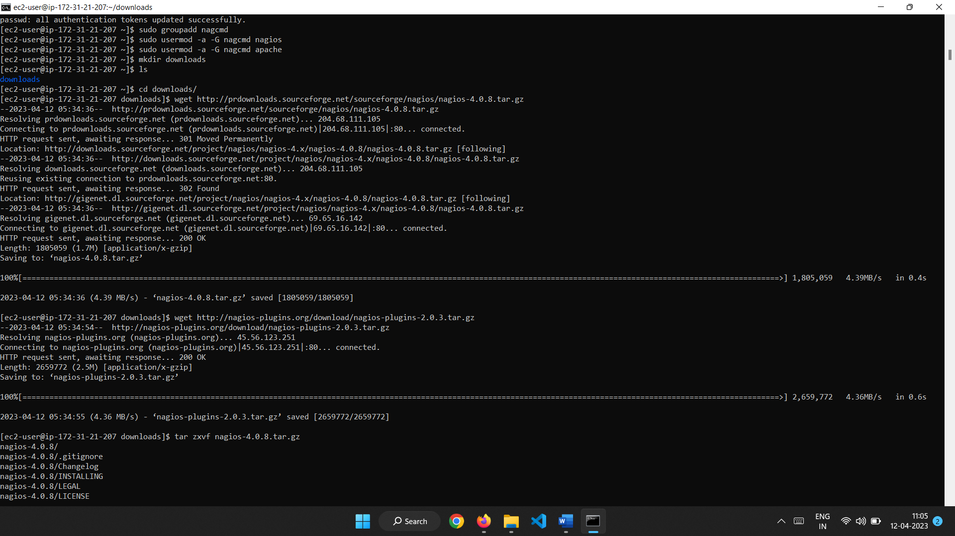

**Step 4: Unzip and Install Nagios**

tar zxvf nagios-4.0.8.tar.gz

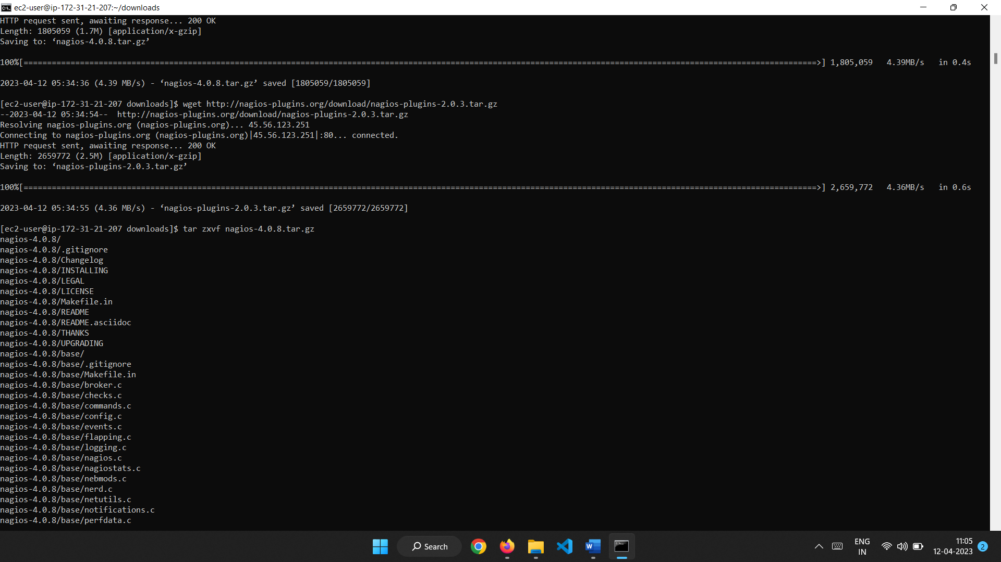

Change the directory to nagios-4.0.8 by using cd command

Run the configuration script with the name of the group which you have created in the above step. **./configure --with-command-group=nagcmd**

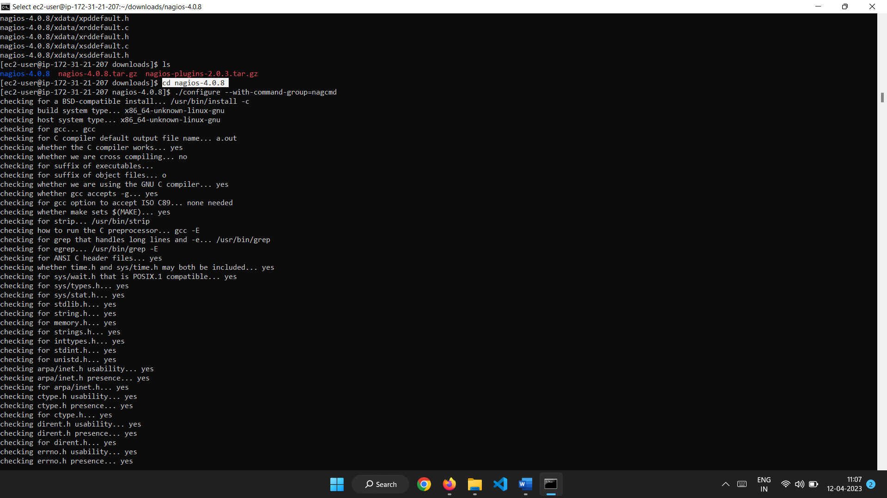

Compile the Nagios source code using command –make all.

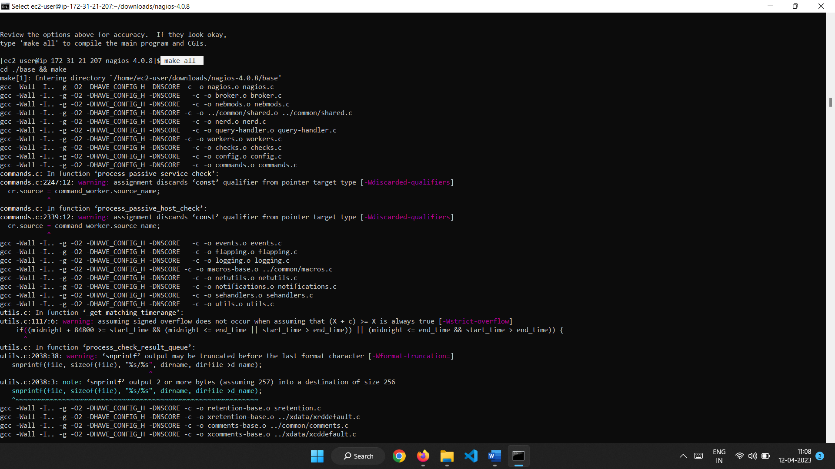

Install binaries, init script, sample config files and set permissions on the external command directory.

**sudo make install**

**sudo make install-init**

**sudo make install-config**

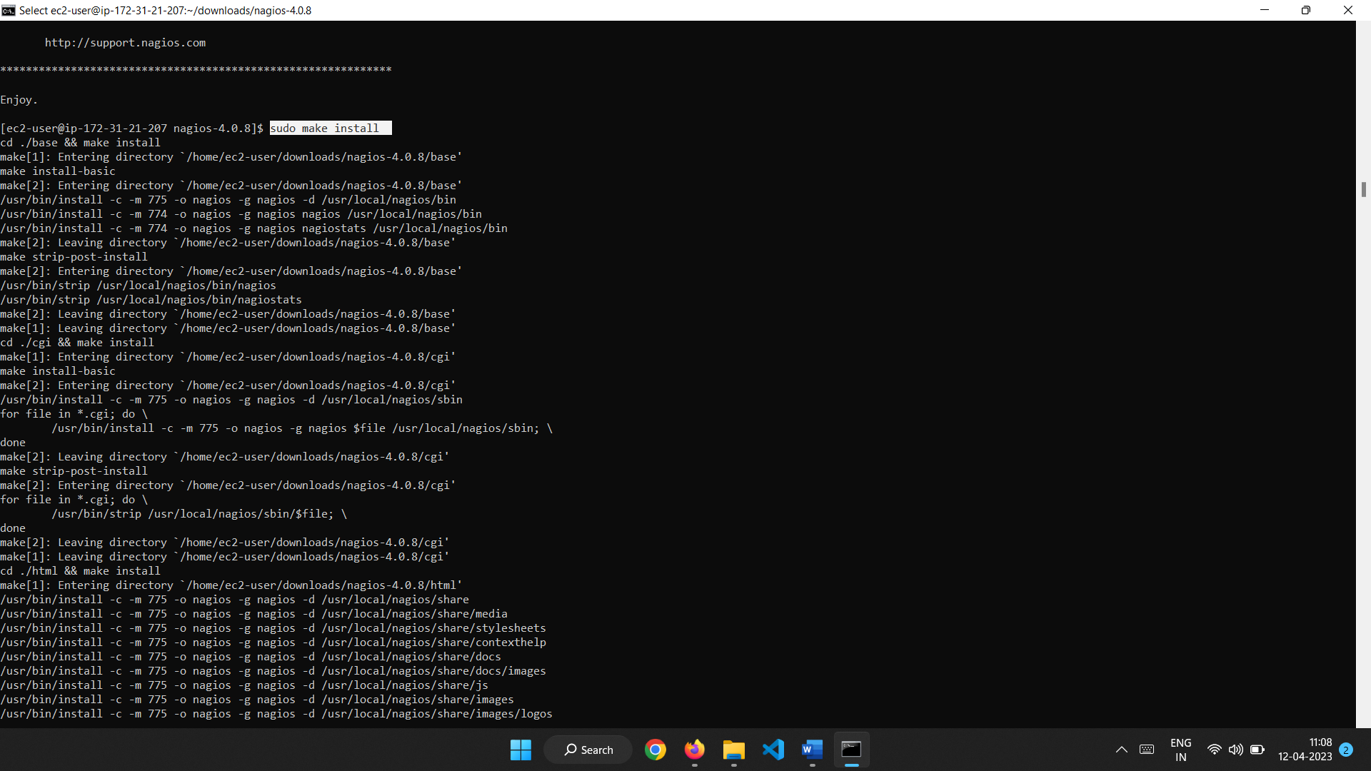

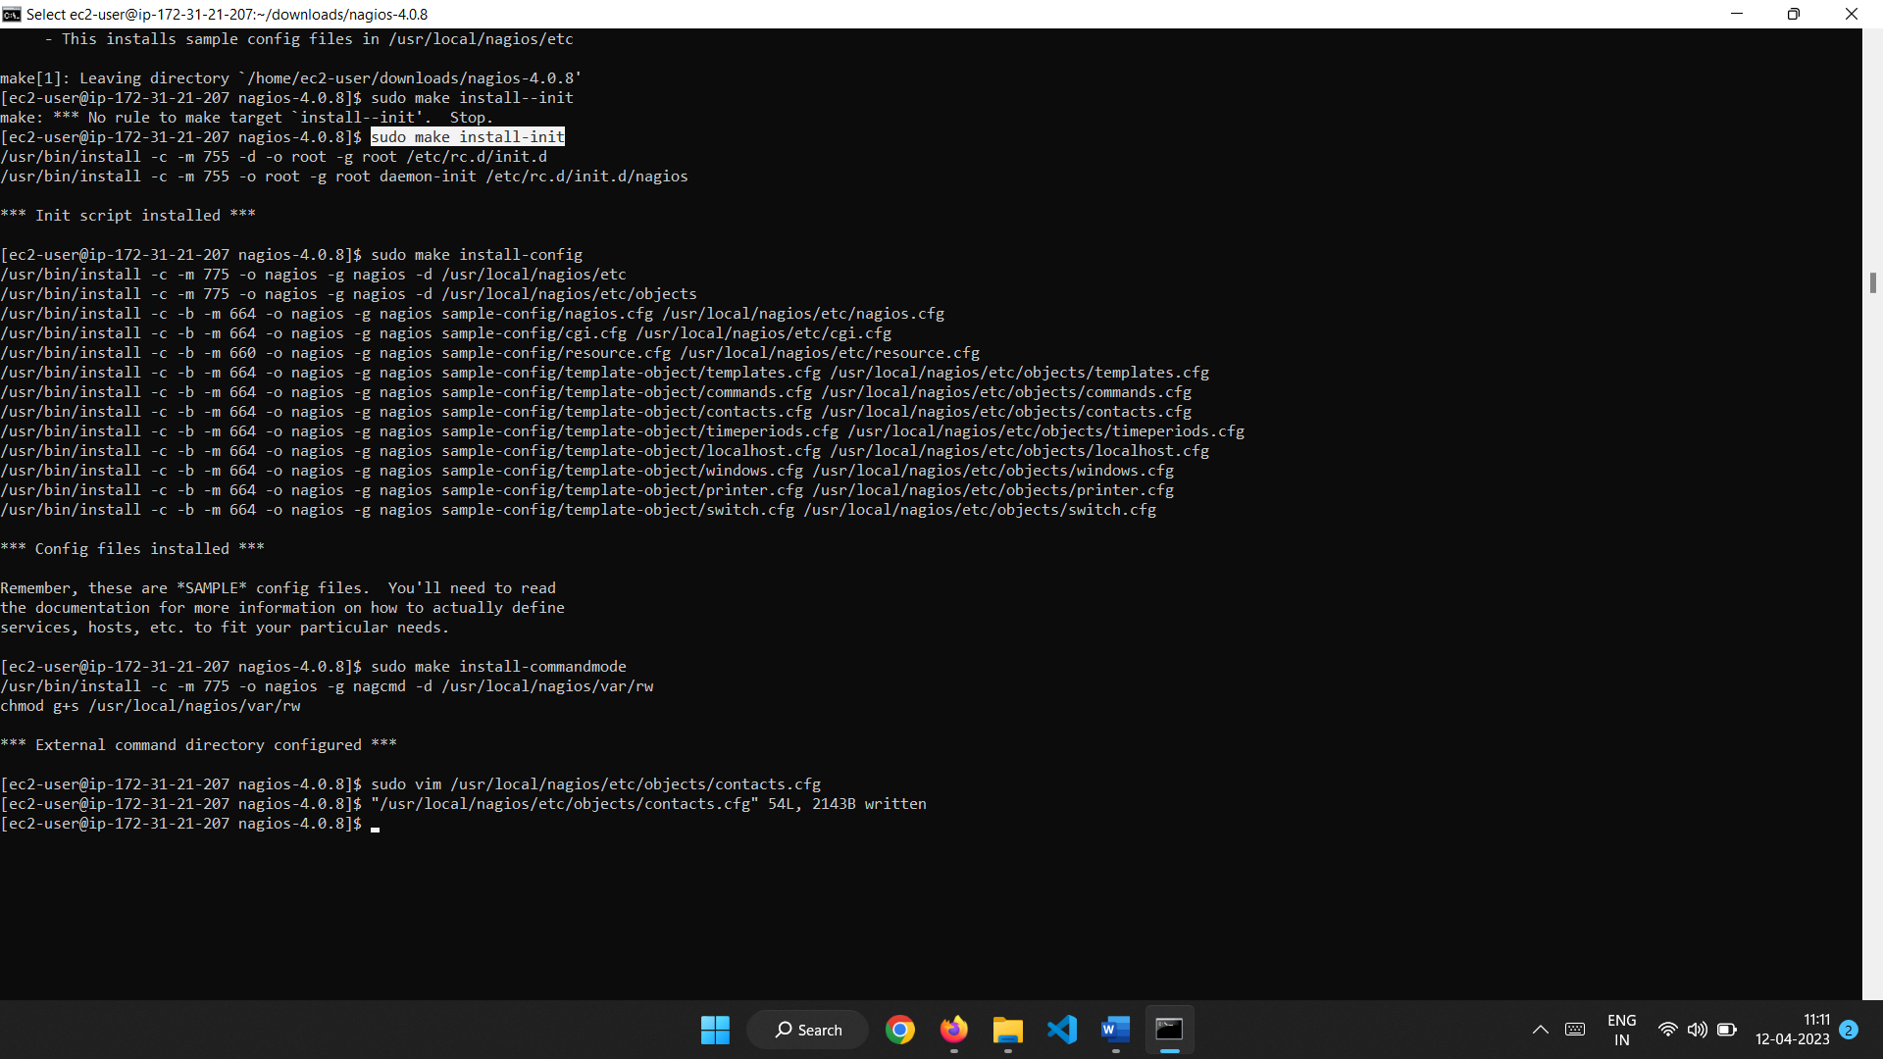

**Step 5: Customize Contact Configuration**

sudo vim /usr/local/nagios/etc/objects/contacts.cfg

Change E-Mail address with nagiosadmin contact definition you’d like to use for receiving Nagios alerts.

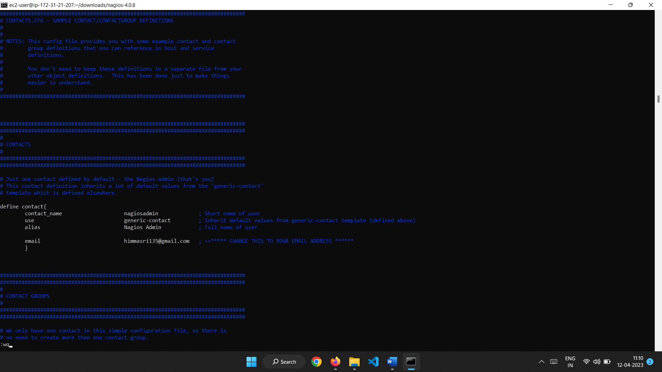

Step 6: Configure the Web Interface

sudo make install-webconf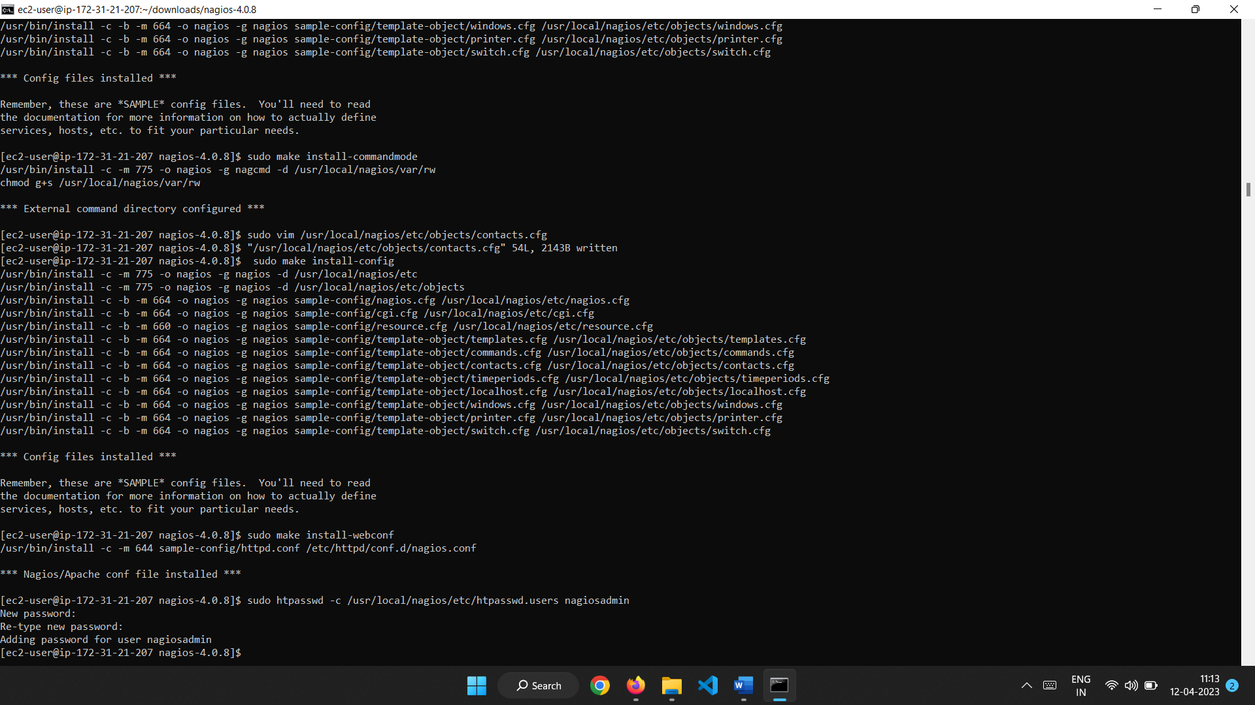Create a nagiosadmin account for logging into the Nagios web interface. Note the password you need it while login to Nagios web console.

**sudo htpasswd -c /usr/local/nagios/etc/htpasswd.users nagiosadmin**

Restart the httpd service.

**sudo service httpd restart**

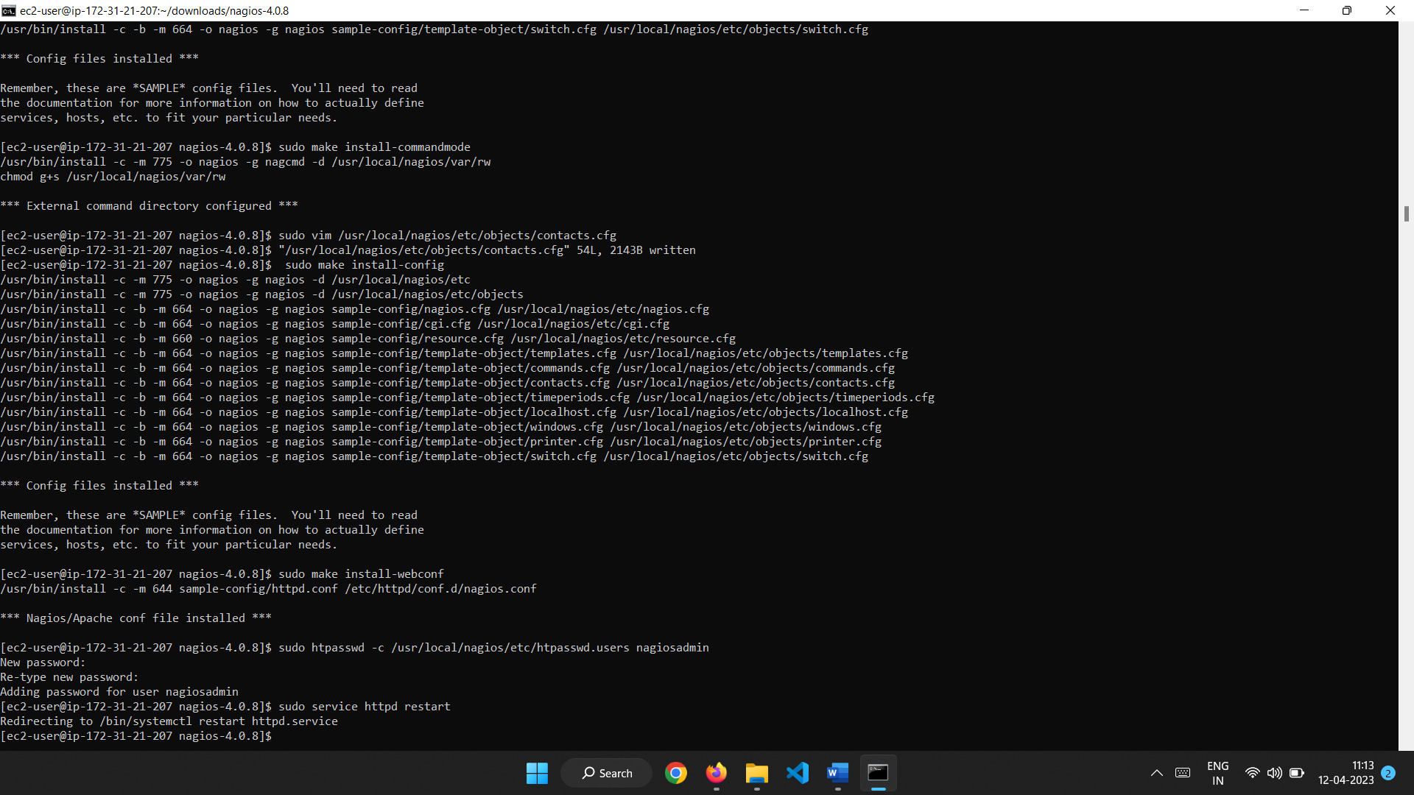

**Step 7: Compile and Install the Nagios Plugins**

Extract the Nagios plugins source code tarball.

**cd ~/downloads**

**tar zxvf nagios-plugins-2.0.3.tar.gz**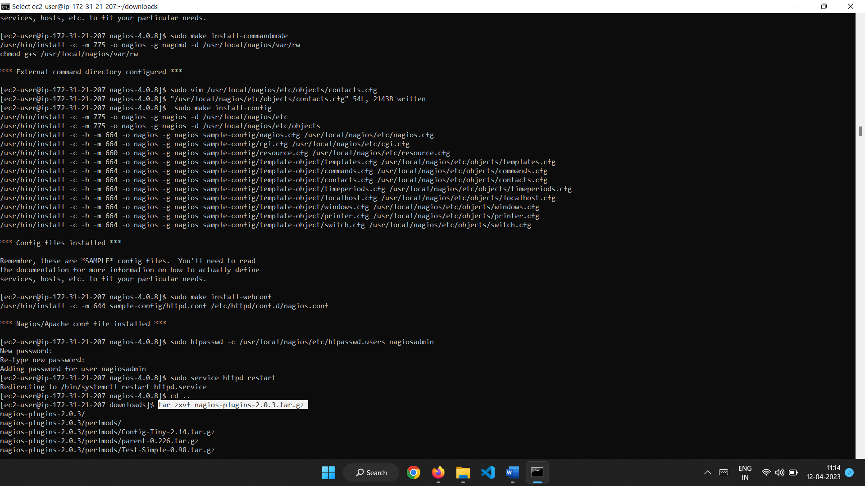

**cd nagios-plugins-2.0.3**

Compile and install the plugins.

**./configure --with-nagios-user=nagios --with-nagios-group=nagios**

**make**

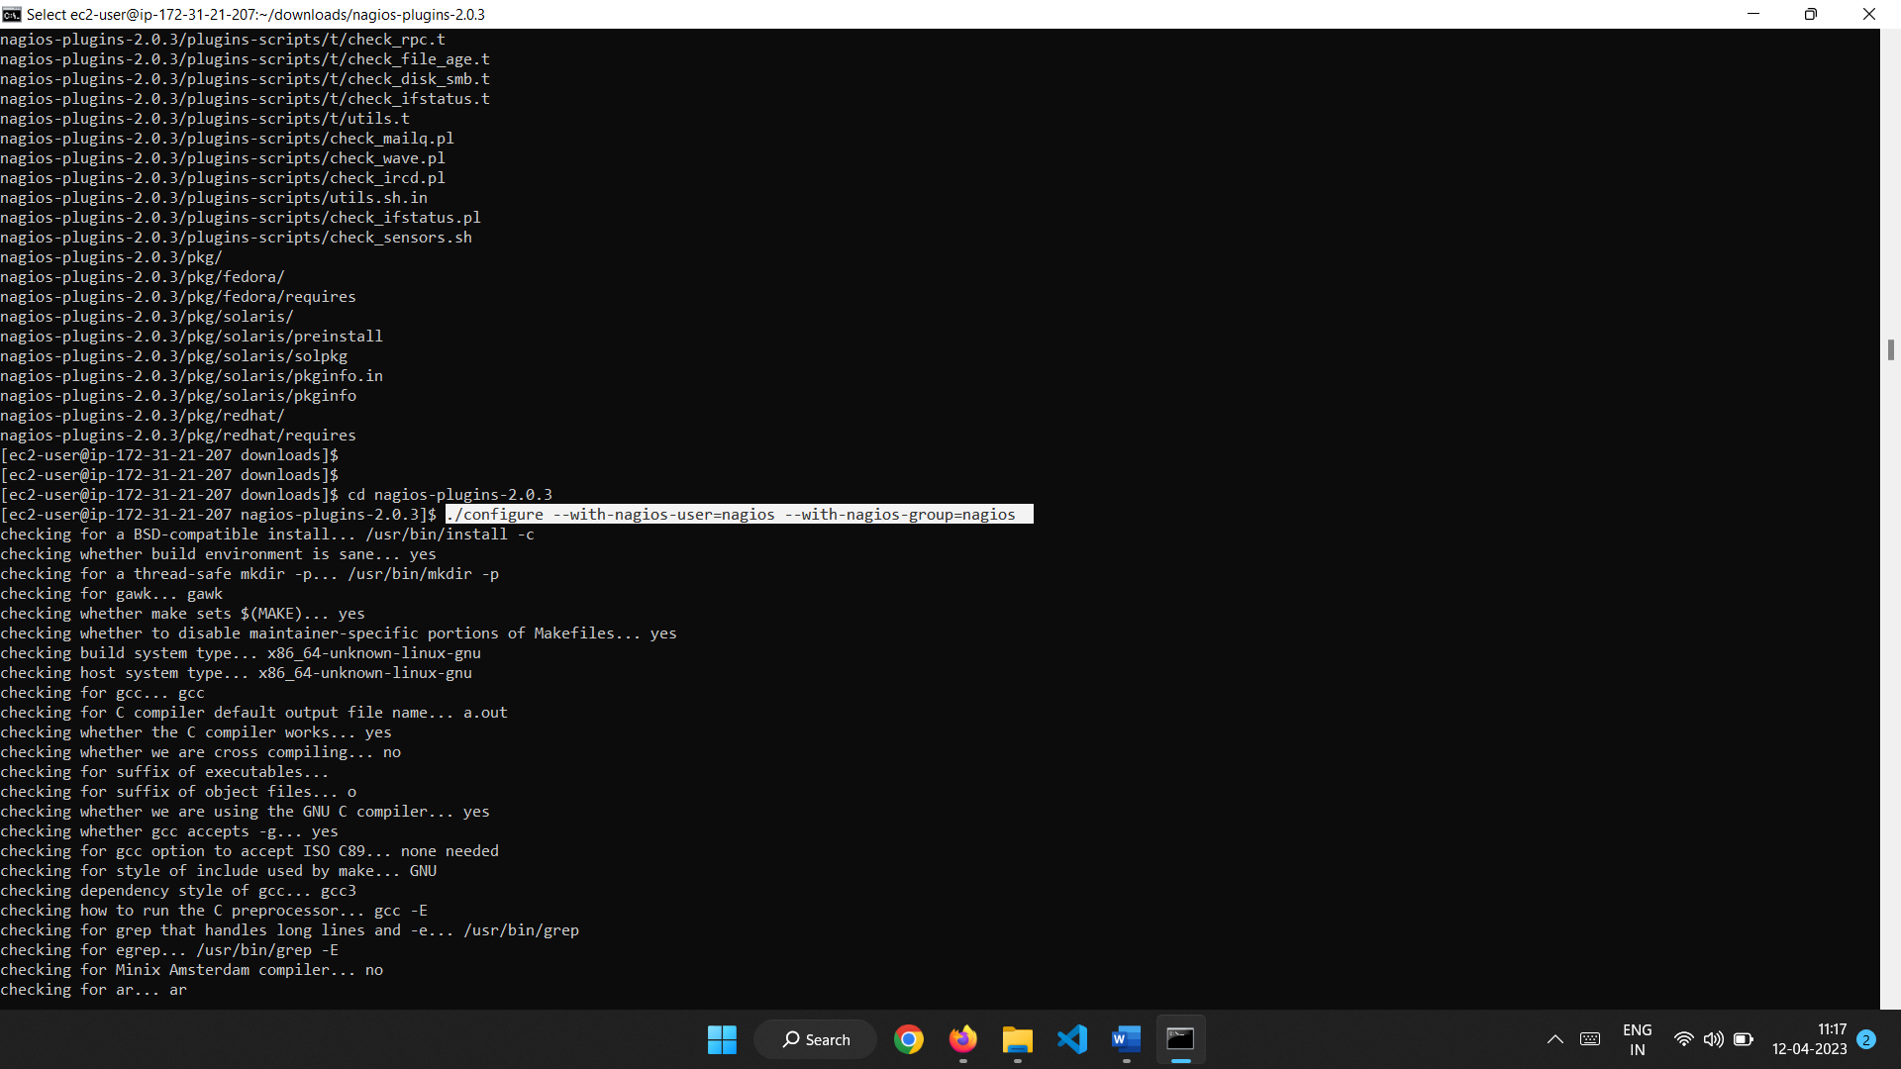

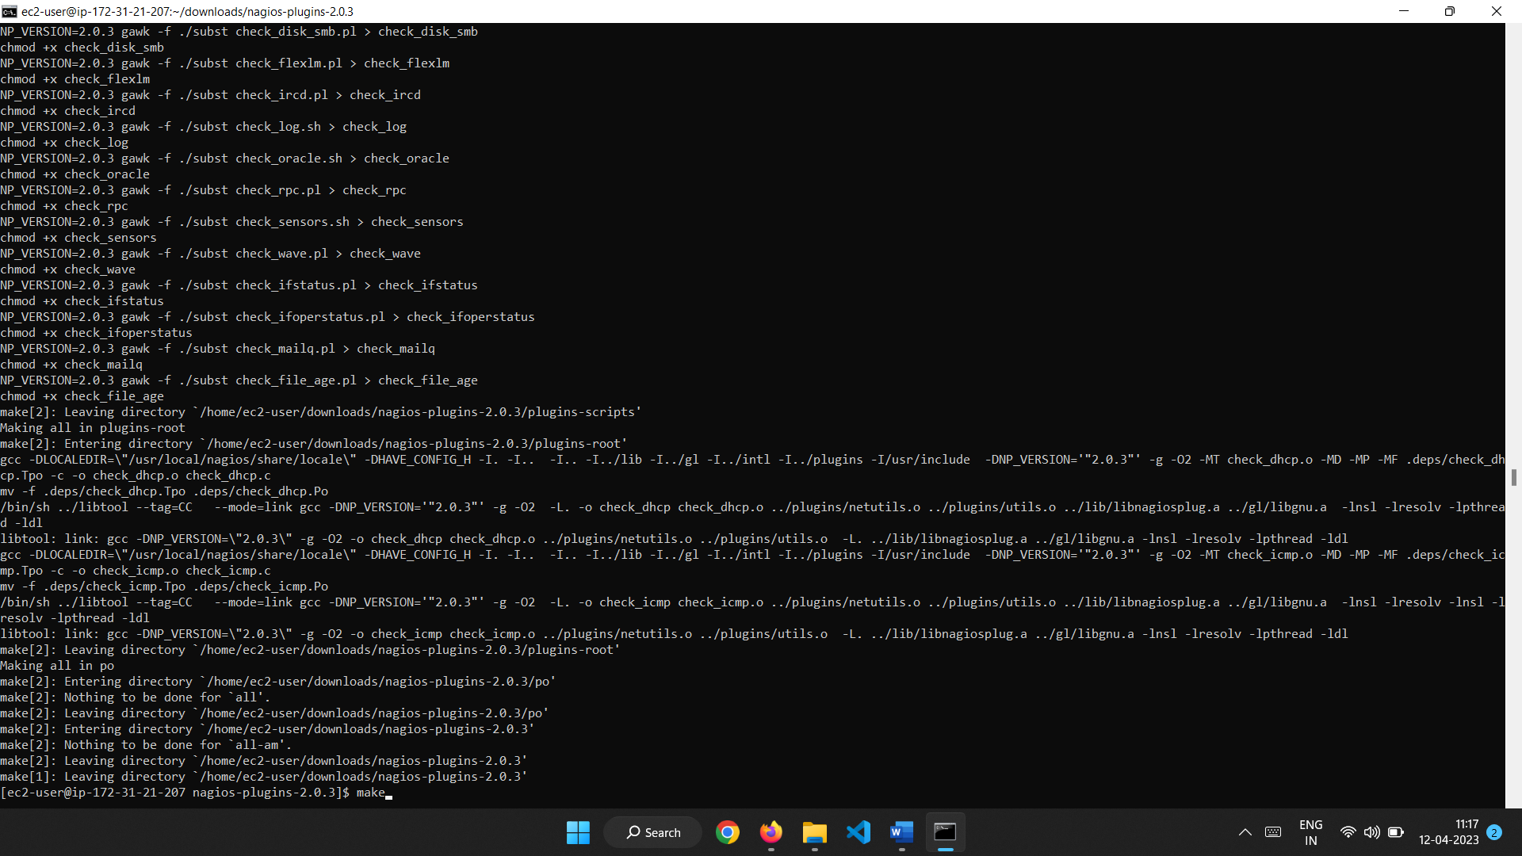

sudo make install

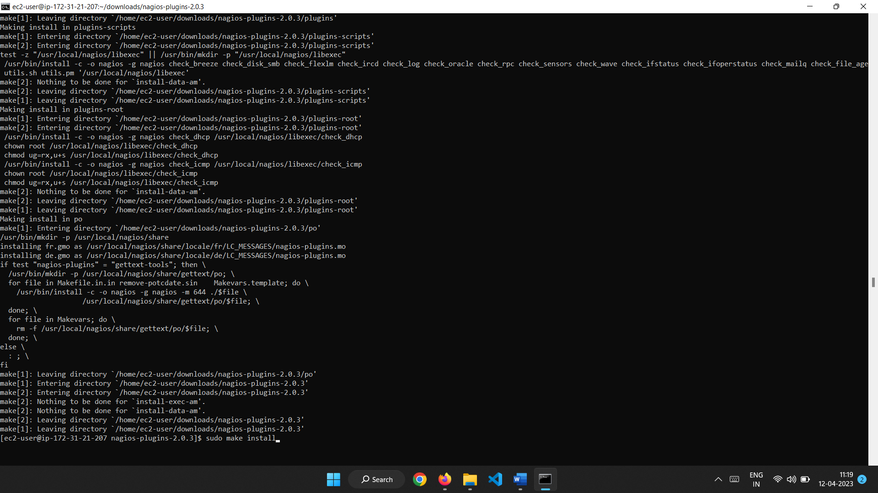

**Step 8: Start Nagios**

Add Nagios to the list of system services and have it automatically start when the system boots.

**sudo chkconfig --add nagios**

**sudo chkconfig nagios on**

**sudo service nagios start**

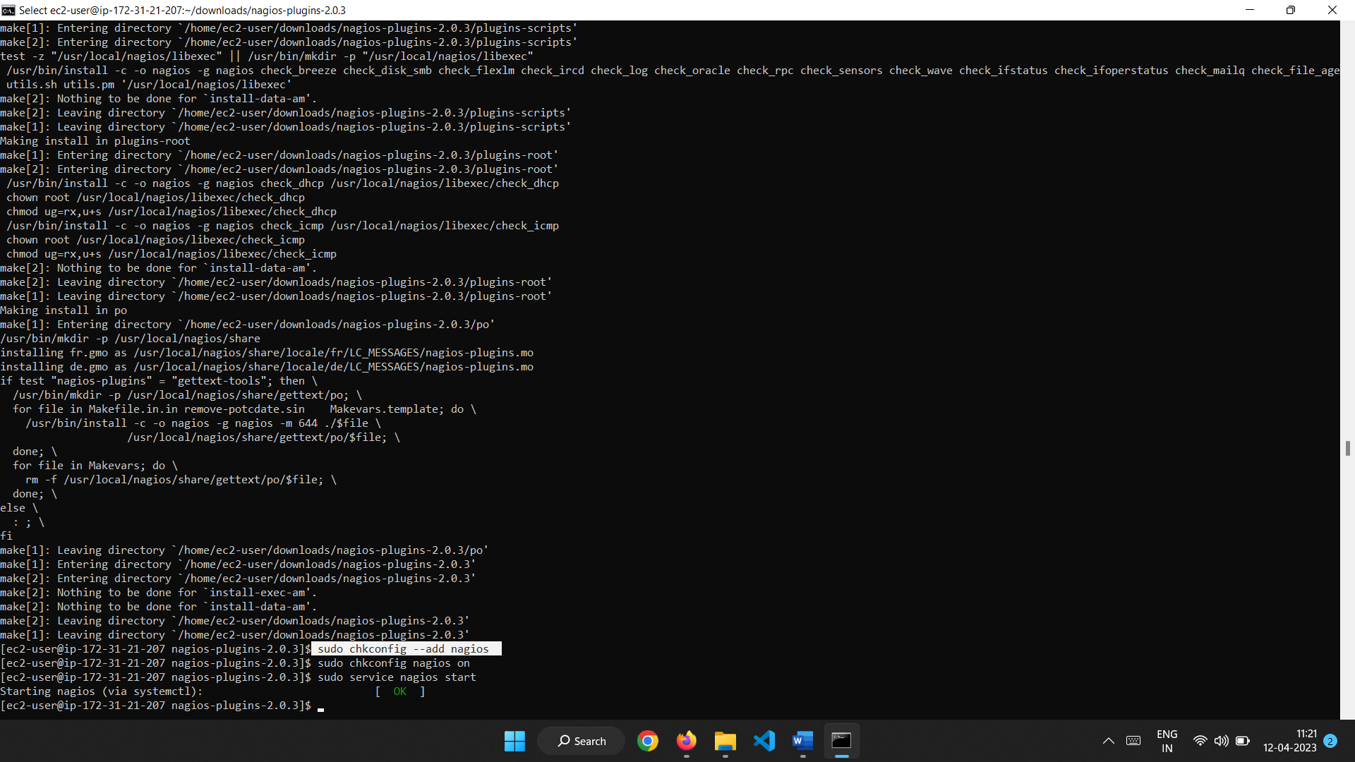

Access the Nagios page using the instance public ip address.

Ec2ipaddress/nagios/ -- this will open the nagios web interface and it will prompt for username(nagiosadmin) and password you mentioned earlier.

After entering the valid credentials you can see the NagiosCore webpage.

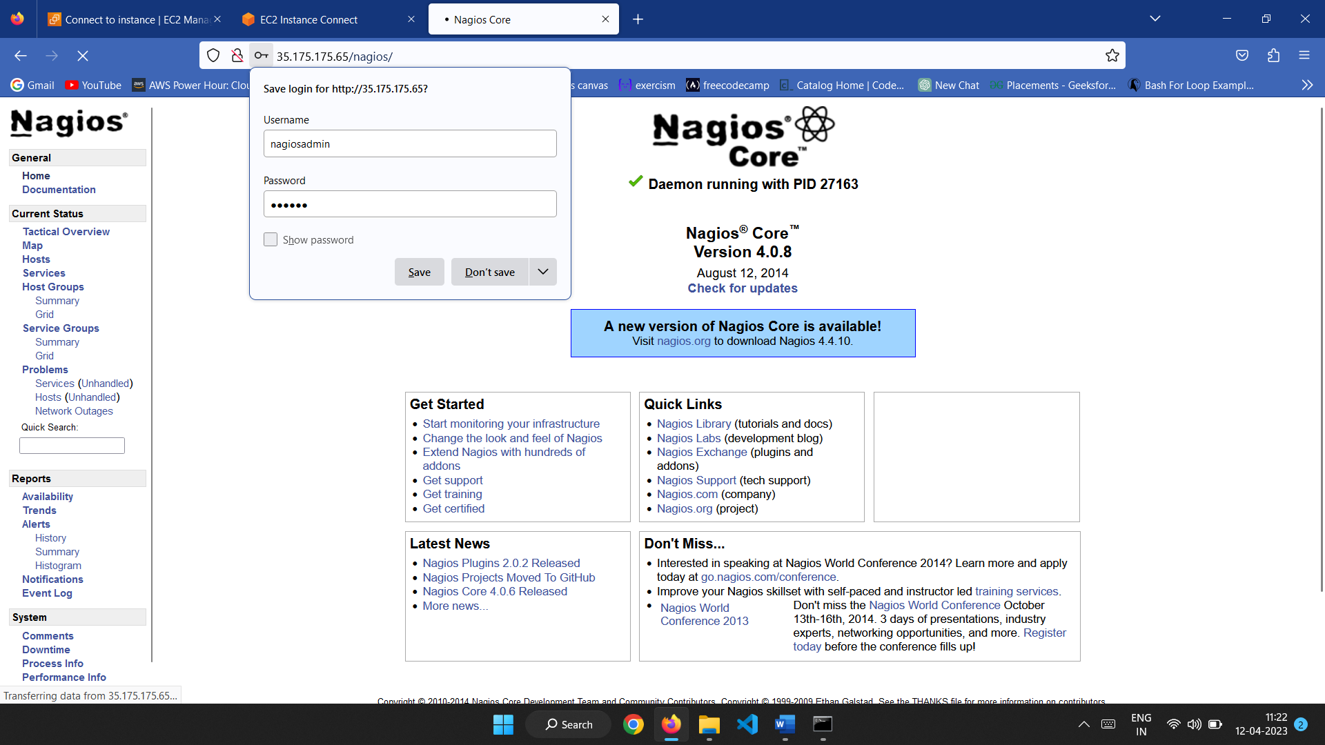

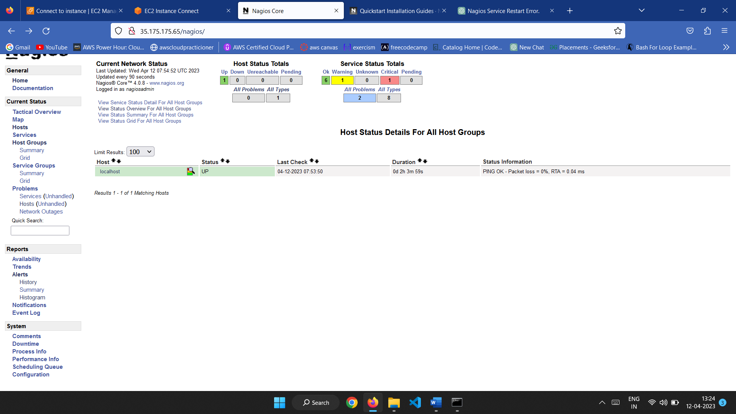

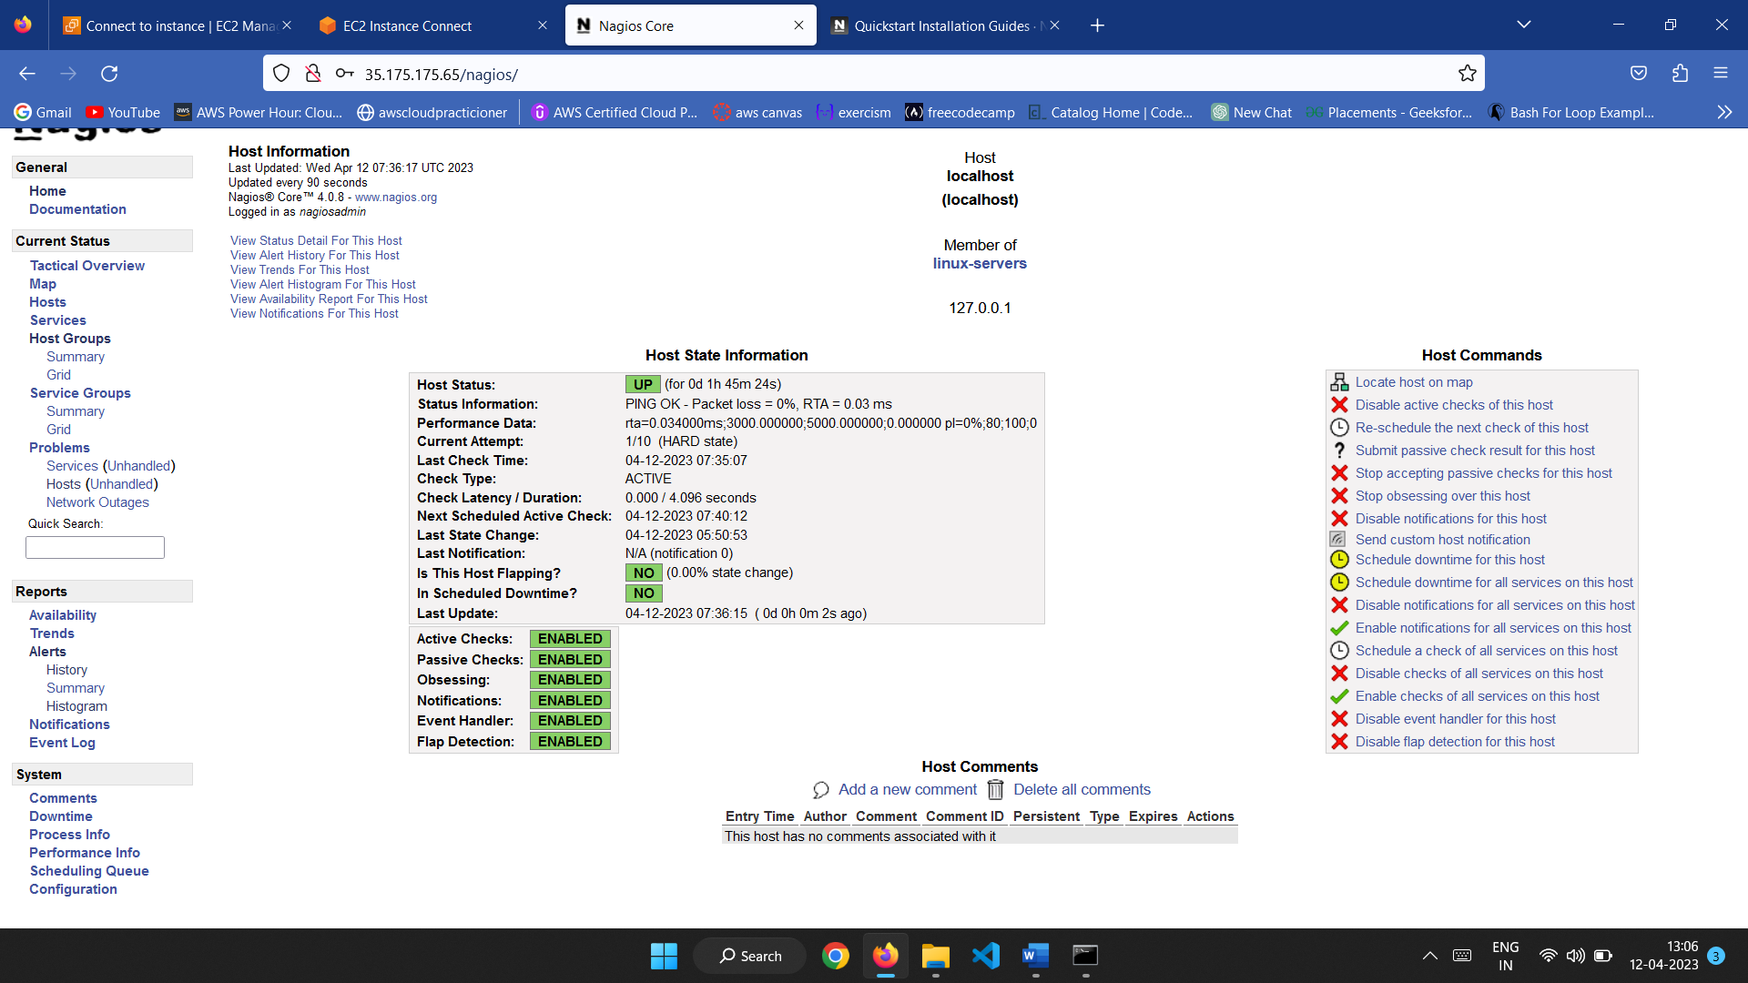

Now,swtich to the ssh directory and change the authentication and password rules.

cd ssh

ls

nano sshd_config

Change the rules:

#PermitRootLogin yes ---> PermitRootLogin yes

#PasswordAuthentication yes---> PasswordAuthentication yes

Now save the changes.

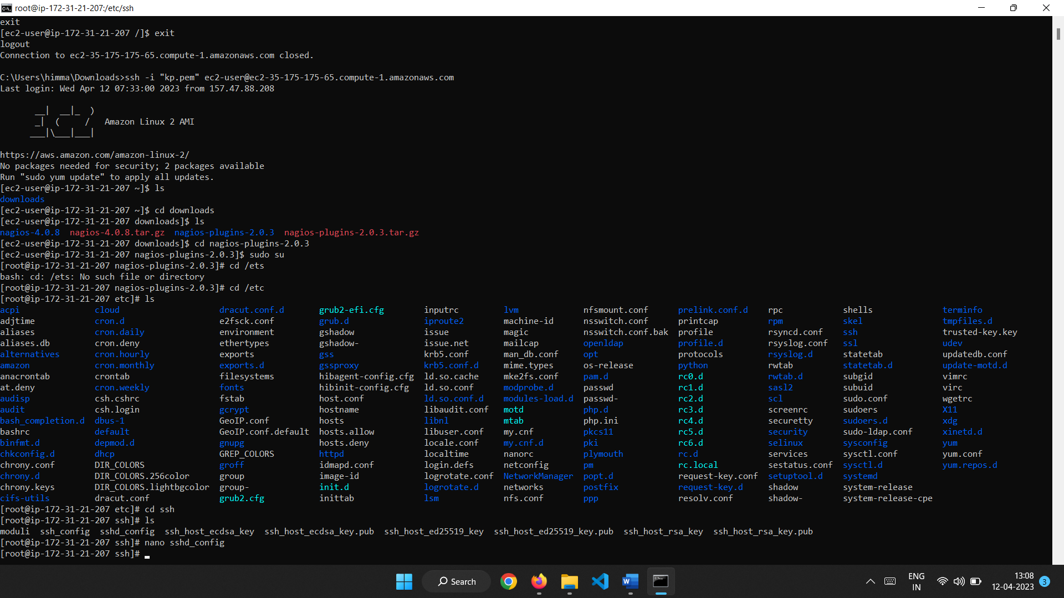

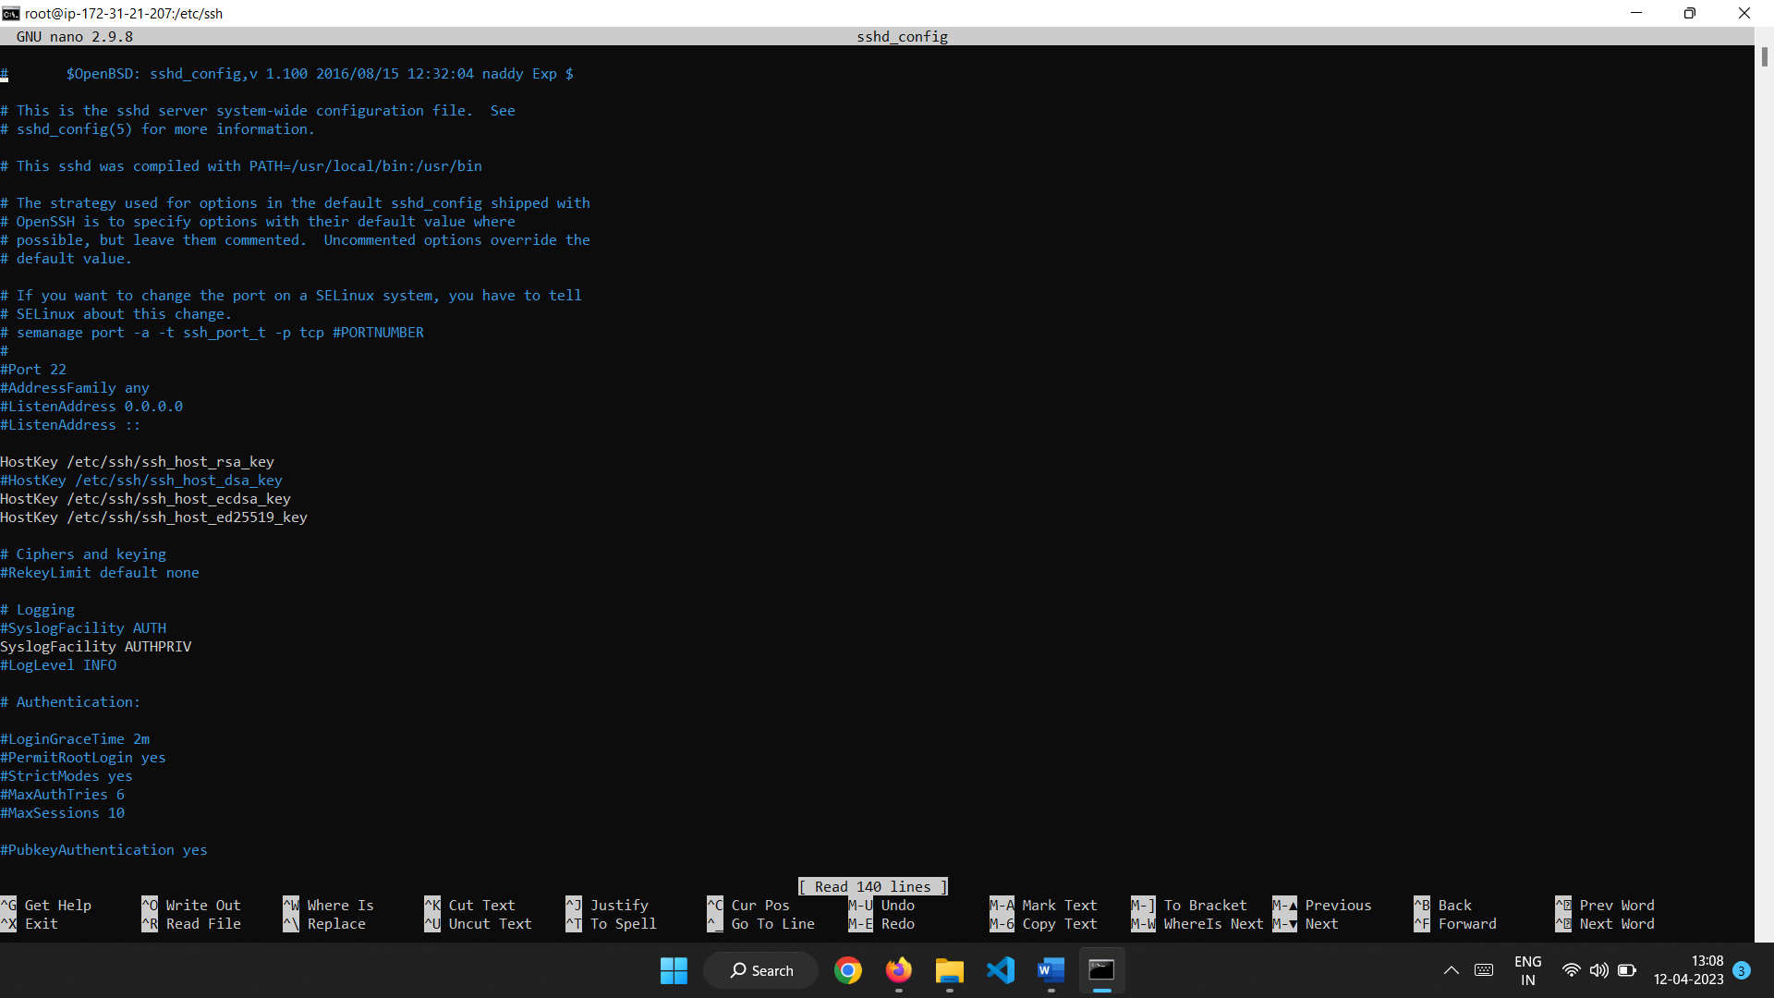

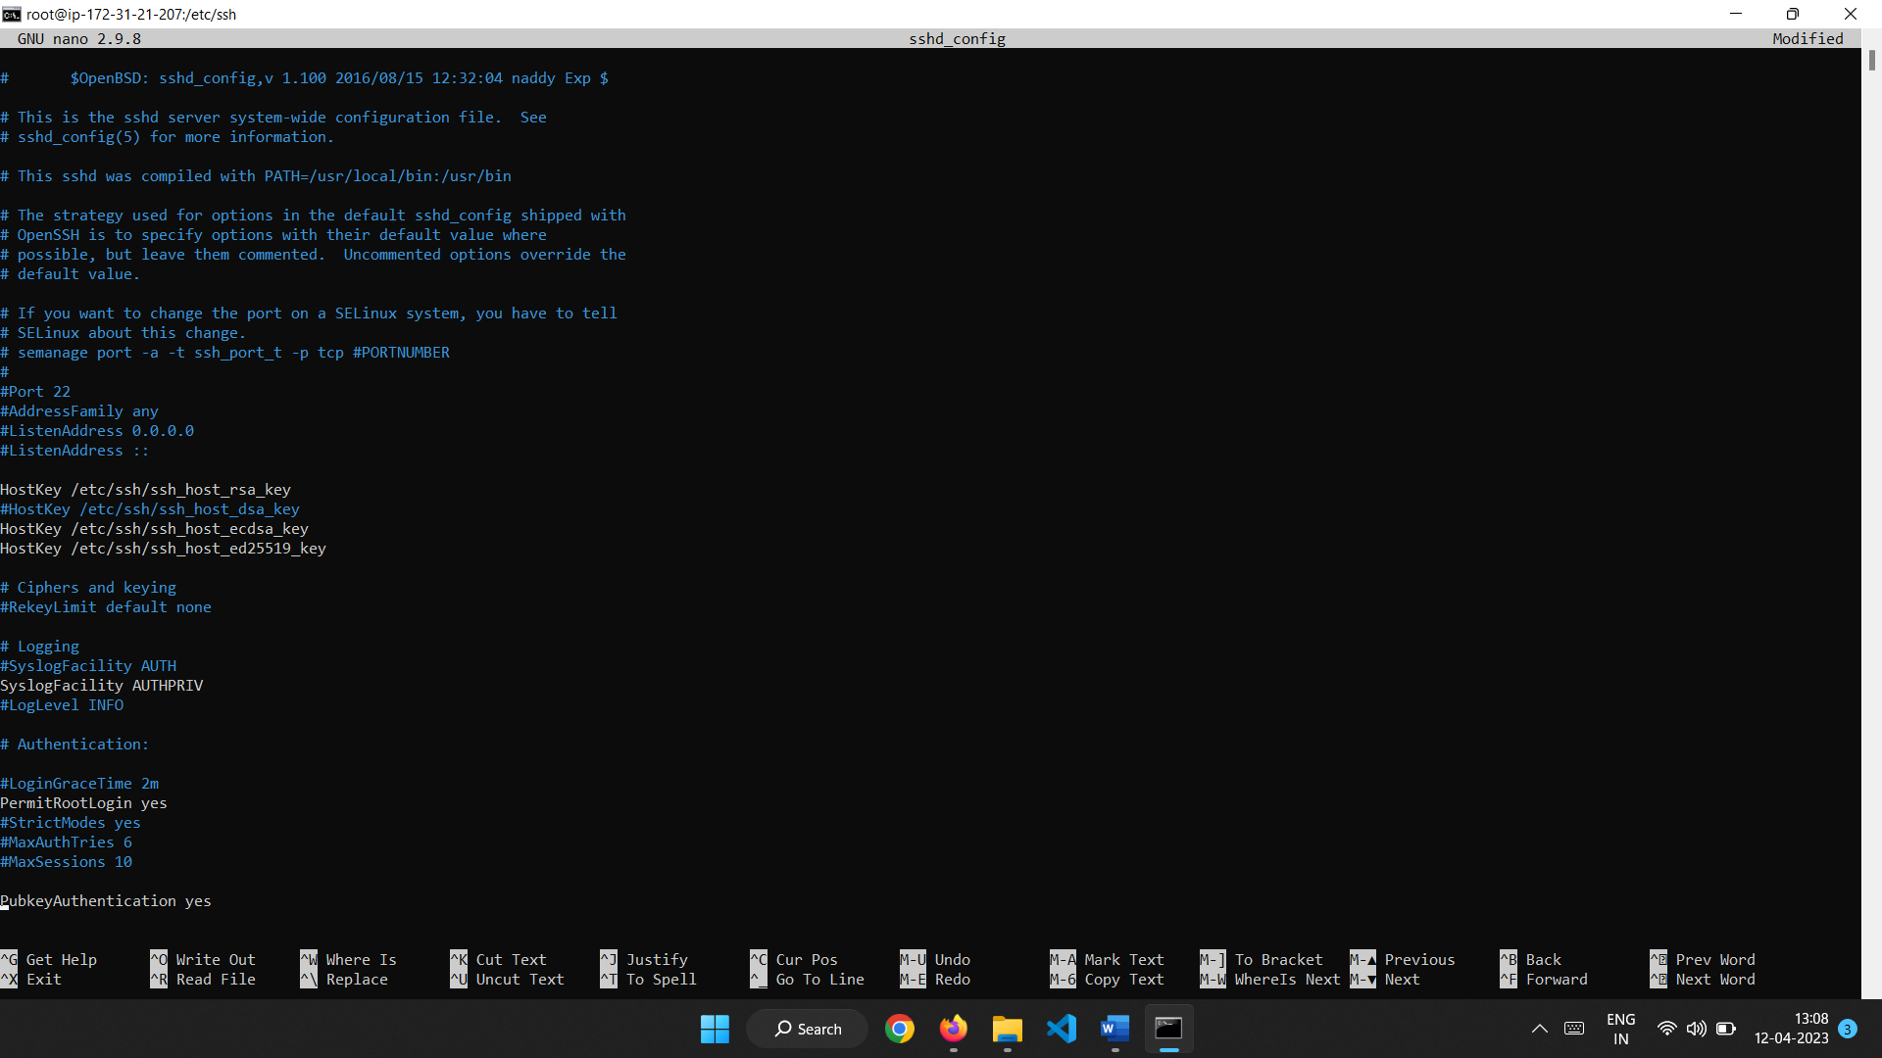

3.Generate the password for the login and restart sshd.

passwd root

systemctl restart sshd

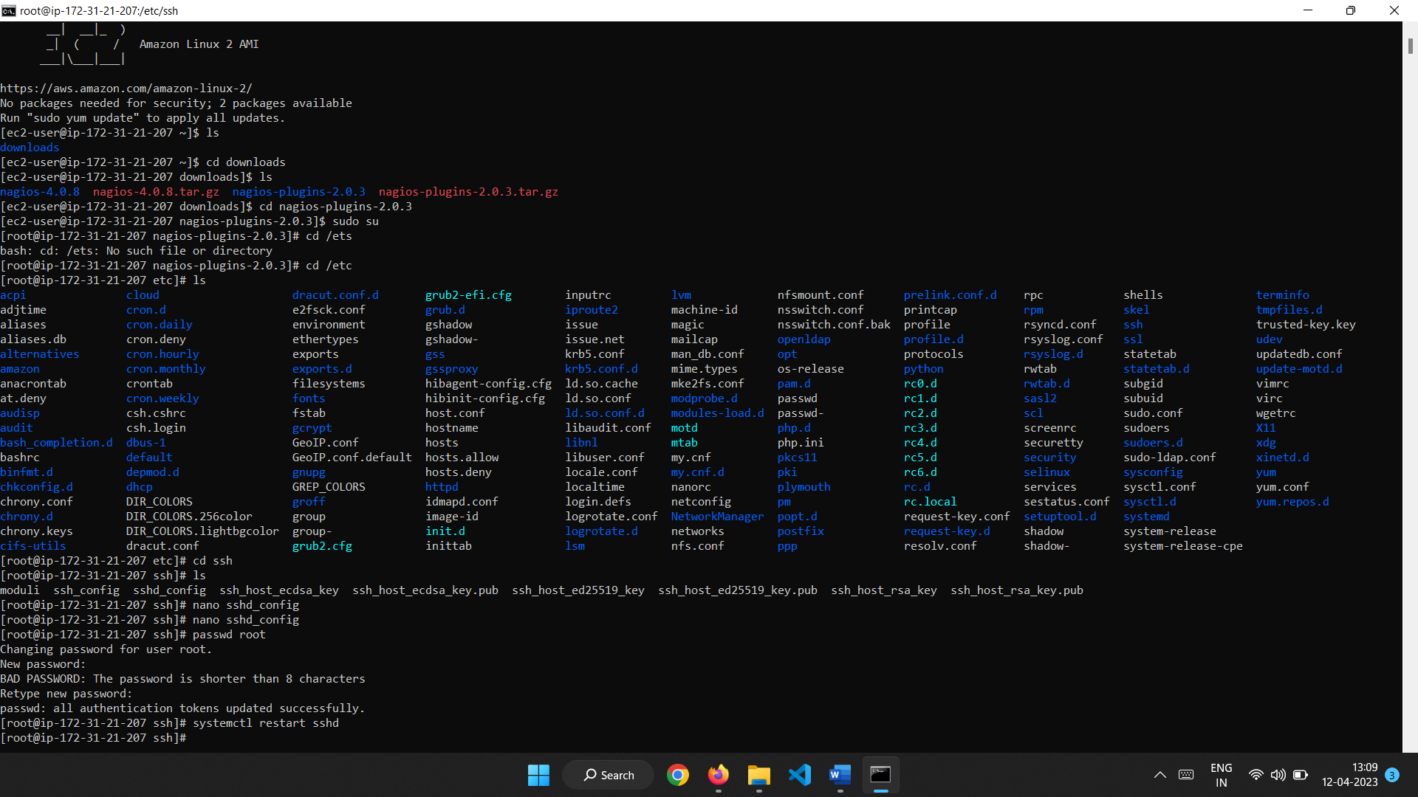

Install WinSCP tool for generating and modifying the configuration files instead of using command line interface or local machine.

Connect by using the instance ip address ,username and password.

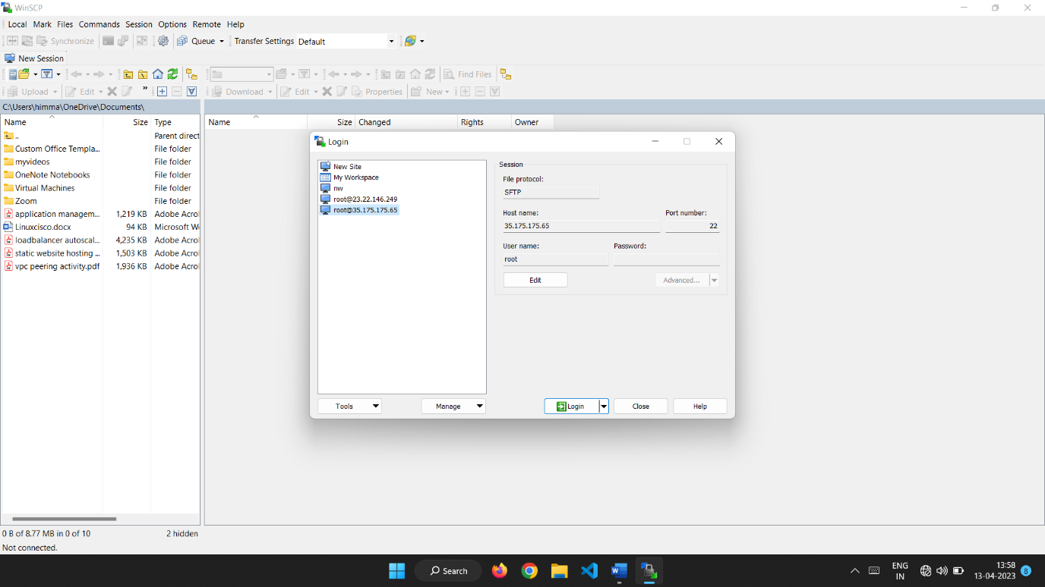

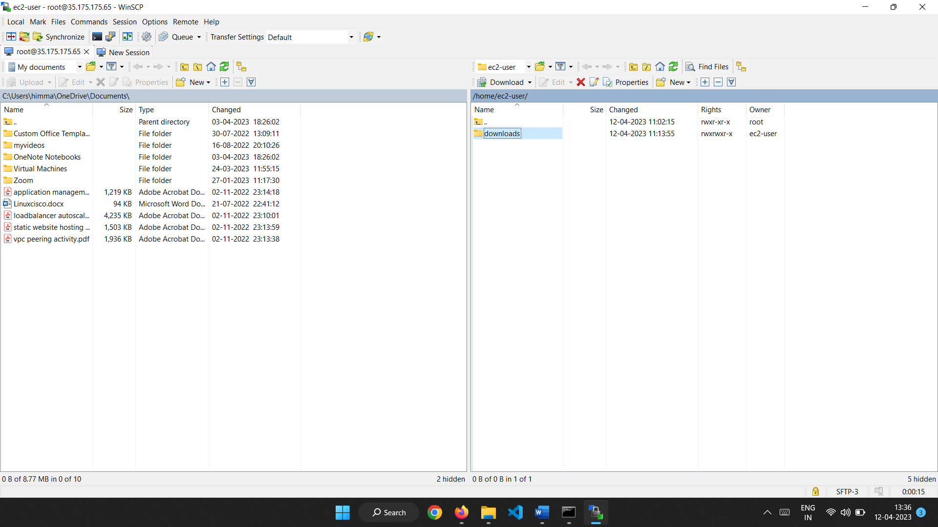

Navigate to the /usr/local/nagios/etc/objects/ to access localhost.cfg (configurationfile) to change the ip address to be monitored.Here, using codemind ip address 210.212.210.86 .

Now restart the nagios.

